|  |
| --- |
| Disaster Recovery – Cloud Provider Runbook Template |
|  |
| Run Book Reviewed and Updated  Month/Year |

##### Contents

Objective 3

Recovery Types 3

MANAGING YOUR ZERTO INFRASTRUCTURE 4

Online Zerto Certifications and Learning 4

Feature Requests 5

Zerto ZVM Requirements 8

Zerto ZCA Requirements 10

Zerto ZCM Requirements 10

Zerto Sizing 10

Zerto External SQL Database – Required for All Cloud Providers 15

Required Automated Billing Setup and Testing 15

Platform Administration, Installation, and Documentation Guides 18

Automation Documentation 20

Provider Best Practices 20

Upgrading the Zerto Infrastructure 24

Cloud Provider Deployment information 27

Zerto Network Requirements - Cloud 27

Zerto Cloud Connector (ZCC) Deployment and Networking Configuration 31

Internal Zerto Infrastructure Details 35

Accessing Recovery Tools 41

Network access 41

Zerto Access 41

Key Personnel Contact Information 41

CUSTOMER DEPLOYMENTS 42

Tenants Portal 42

ZORG Name – Customer #1 48

ZORG Name – Customer #2 51

Internal MSP Application Recovery Plans 54

VPG Failover Order 54

Procedure for Failover of <VPG NAME> to Recovery Site 55

Troubleshooting and Support 57

Initial Troubleshooting Steps and Knowledgebase Articles 57

Zerto Support Services 60

Objective

The objective of this document is to help Zerto’s Cloud Service Providers to continuously implement, scale, maintain, and document their Zerto Infrastructure. This “fill-in-the-blanks” guide will help MSPs streamline day-to-day activities, aid for when coverage is needed, assist new hires, and ensure best practices.

Instructions

Throughout this guide you will find areas of information that will be highlighted, much like this section, to indicate that this information should be changed to reflect your environment/company. If the information does not apply, it can be removed from the Runbook completely. Likewise, you can build extra sections that directly apply to your company protocols or infrastructure. Once you have completed this book you can also delete this section as well.

After updating this runbook make sure to regenerate the Contents Index on the next page to reflect any changes that have been made. To do this, simply click within the contents box and view the menu toward the upper left corner. An update table button will appear. Click Update Tables, then select update all, and click OK.

Recovery Types

Zerto provides several types of recovery methods and it is important to familiarize oneself with each. This will help to ensure that the proper recovery actions are not only understood, but also correctly executed during the event of an outage.

Move - If there can be a proactive response to a known threat Zerto offers a Move VPG function to migrate a workload to a recovery site prior to a service interruption (I.E. maintenance outages). If, however an event has already occurred then there are still two more ways to recover.

Live Failover – If an event has occurred and there is reason to believe that the production system will be out of service for a lengthy period of time, a Live Failover operation is the proper action to take. This will cause Zerto to bring that application online at the recovery site.

Journal File Level Recovery – If applications are still online, but a file(s) or folder(s) have been corrupted, then Zerto’s File Level Recovery function would be the proper solution. This allows for file level recovery at a granular level (journal checkpoints) to a time just before the corruption, while preventing the necessity of failing over the entire VM to a point-in-time.

Test Failover – This function of Zerto is for testing the recoverability of an application. It should not be used during a real event as it isn’t designed to initiate a reverse replication operation. Testing frequently and often is recommended.

Offsite Clone– When extending testing capabilities for longer than the allotted journal size, use the Offsite Clone. The Clone is a copy of the protected virtual machine, located on the recovery site, while the virtual machine on the protected site remains protected and live. For more information on when to use Offsite Clone Vs. Test Failover, please refer to page 9.

LTR/Backup – This feature is an extension of the Zerto Journaling and allows for a longer retention, past the 30 day limitation of the previous operations. If the known VM corruption or problem occurred outside of the length of the VPG’s journal retention, then Zerto’s LTR/Backup is the correct recovery solution.

If you would like to learn more about Zerto and its full capabilities, all documentation is publicly displayed at the following online location:

<https://www.zerto.com/myzerto/technical-documentation/>

# MANAGING YOUR ZERTO INFRASTRUCTURE

Important: All Zerto documentation is publicly displayed on our technical documentation page. This documentation is continuously updated and should be reviewed prior to making any changes in the Zerto environment, internal or external to the Zerto product (I.E. Host version upgrades, Hypervisor upgrades, etc.). The Zerto Technical Documentation page can be found at the link below:

<https://www.zerto.com/myzerto/technical-documentation/>

## Online Zerto Certifications and Learning

myZerto University is an online learning portal that delivers the training you need to be successful with Zerto. All employees working within your Zerto environment should be required to complete these training courses. Once an employee completes their first Zerto certification, they will be required to continuously enroll into our new maintenance tracks, which are simultaneously released with our newest software versions. This will ensure that your employees have a good fundamental understanding of Zerto and stay up to date with the newest features and releases.

You can access our certifications through our myZerto University page. All courses are complimentary for signed partners. Our certification paths change with each platform or feature release, so if you want the most up-to-date course list for your company, please reach out to your Zerto Account team.

To login and view our current course list, simply login to your myZerto page. Once logged in, you will see a Training tab appear on the top right. Under the dropdown is an option for “myZerto University”, as seen below:

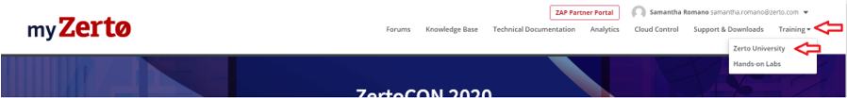

If an employee does not have a myzerto.com login, then they will not have access to MyZerto University. To gain access, they will need to create a user on the MyZerto Portal. The instructions for this are listed below:

Get access to MyZerto University:

**1.** Go to zerto.com/myZerto

**2.** Click ‘Create Login’

* + Create a login using your business email address for registration, otherwise you will not get

the correct courses that are available to your company

* + You’ll receive an email with your password. If you don’t receive it promptly please check

your spam or junk folder. Contact support at www.zerto.com/support if you need assistance. Alternatively, you can send an email to [support@zerto.com](mailto:support@zerto.com) if are having issues with the myZerto login.

**3.** Login

**4.** Once logged in, click ‘Training’ in the upper right-hand corner of the MyZerto navigation menu

**5.** Select your desired course from the ‘My Courses’ section, or enroll from the full Course Catalog

*If you are wondering which training sessions are the most relevant for your company, please make sure to reach out to your Zerto Account team. These courses are continuously updated by Zerto’s Training and Enablement team whenever a new feature or platform is released. Your Account team will be notified on exactly which courses will be most relevant to our MSPs.

Hands-on Labs:

In addition to myZerto University, Zerto has created Hand-on Labs for training. These on-demand labs are designed for a direct hands-on approach to learning our IT Resilience Platform. The labs are perfect for those looking for training on the critical features & functionalities of the software. With built-in step-by-step instructions, these hands-on lab sessions equip learners with the practical skills to setup, configure, and manage Zerto.

1. Navigate to zerto.com/myZerto and login.
2. Once logged in, click ‘Training’ in the upper right-hand corner of the MyZerto navigation menu and select the option for “Hands-on Labs”

1. Once there, browse the page for our current listing of deployable Hands-on labs.

Our Hands-on labs will continuously change and grow over time. Check in periodically to see any new labs and training seminars.

## Feature Requests

Zerto takes a democratic approach to its roadmap. MSPs and customers can personally request ideas or features that they would like to see in the product, and then other users can vote on the idea to move it up the list on our roadmap. If you have any ideas for additions to Zerto’s products, we highly recommend that you either submit the requests or vote on features from our Feature Requests page.

Additionally, if there is an idea in place that you have voted on and would like to monitor the process of, you can also subscribe to the request to do so. Subscribing to a Feature Request will send the user updates when a Product Manager or others comment on its status. It will also alert you if the request is marked as planned, shipped (implemented), will not implement (with explanation), or already exists. The subscribe button can be found on the Features Request itself, seen below:

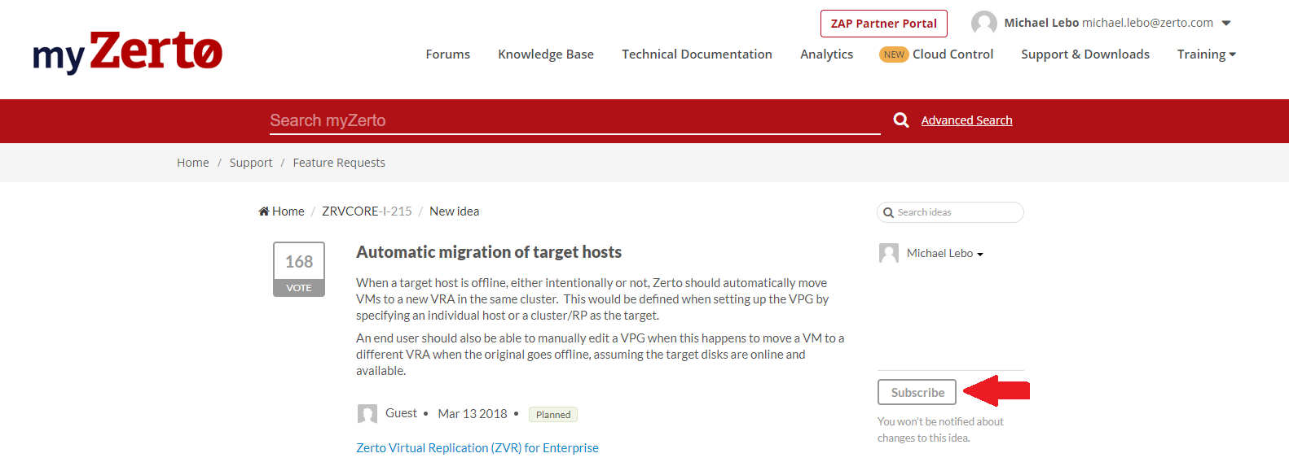

Feature Request process:

1. Navigate to the myZerto.com site and login with your credentials
2. Once logged in, navigate to the “Support & Downloads” tab on the top right:

1. On this page you will have multiple options for downloading Zerto files, creating Support cases and more. Select the Feature Request option from this page:

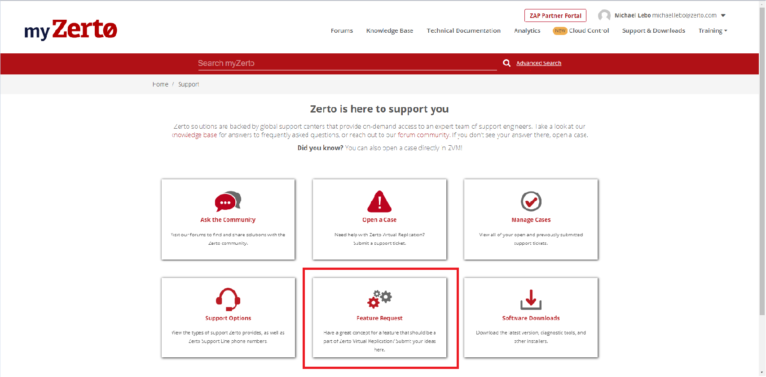

1. On the Feature Request page, you will see a searchable list of the current requests. Always search the list for your idea first and ensure that the request has not already made. If the request is there, simply vote on the request and Zerto’s Product Manager team will be alerted. If the idea is not on the list, select the “Add a new idea” button on the top left:

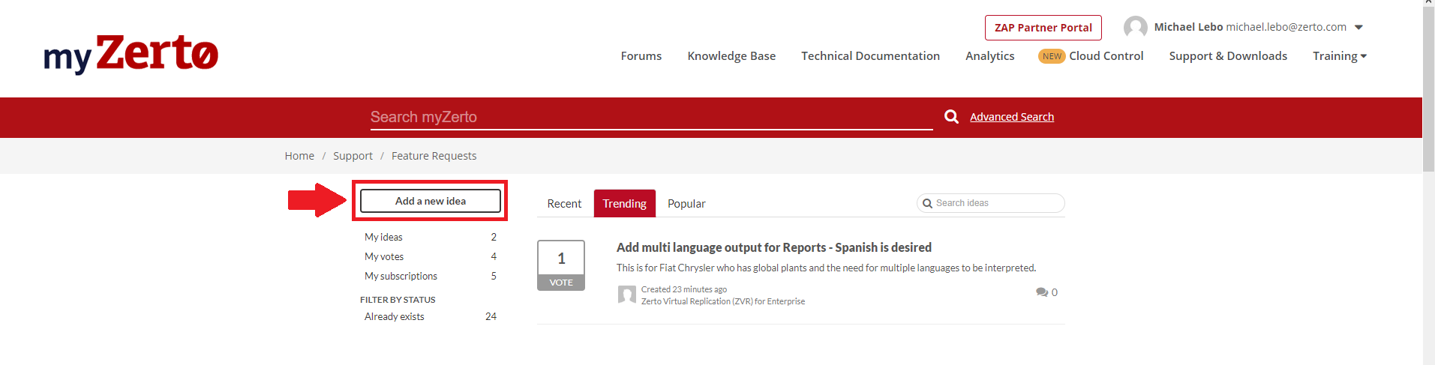

1. To add a new idea/feature request, first select the product type for the idea in the top dropdown, and then fill in the fields that appear after this selection:

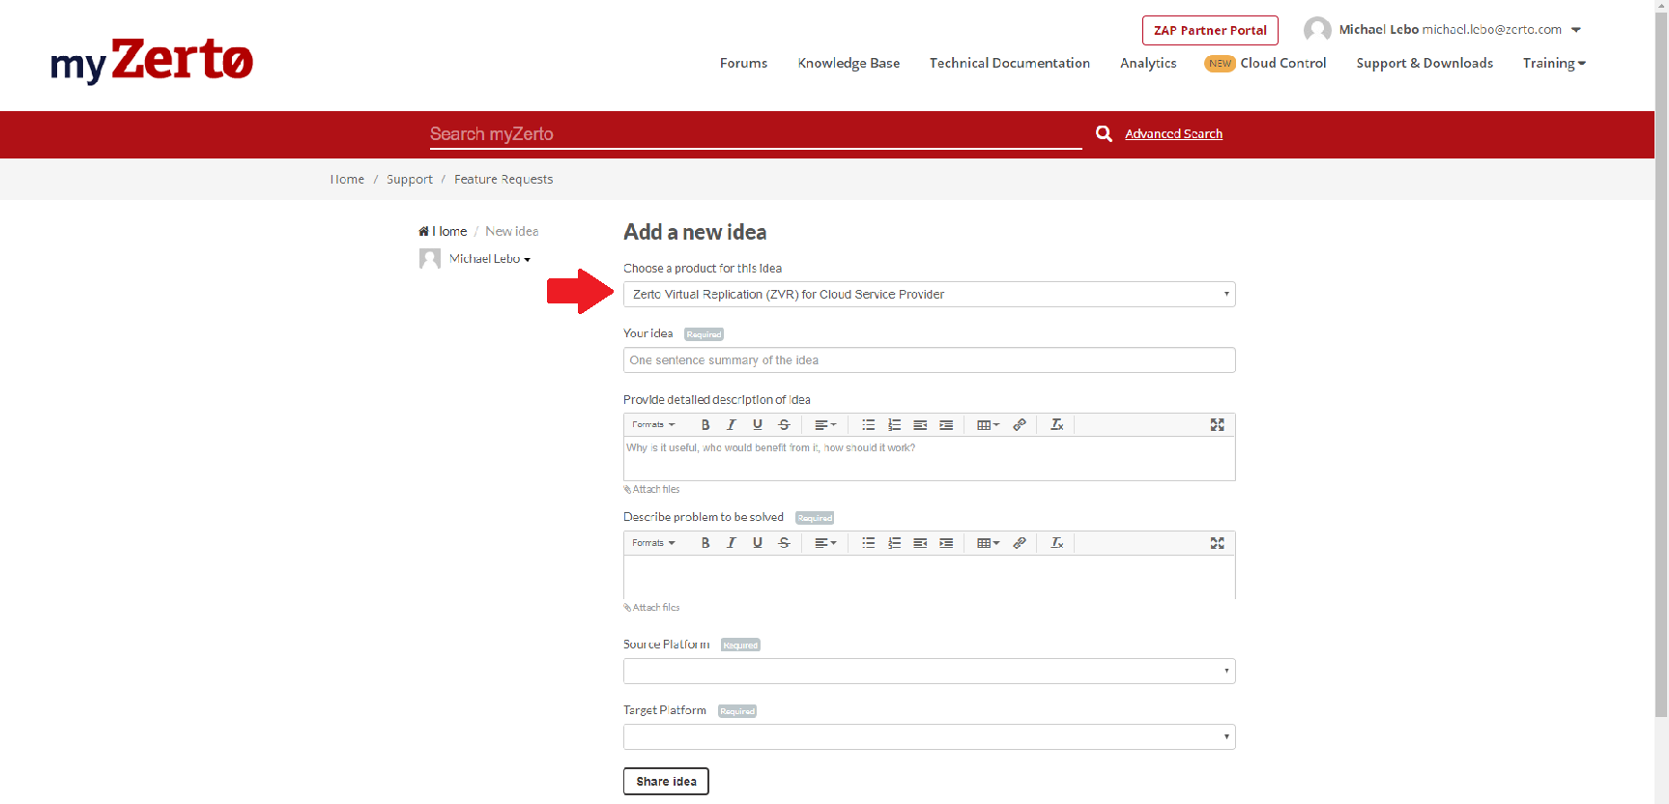

1. Once the form is filled out, you can submit the idea via the “Share idea” button at the bottom of the page. The idea will be sent, and our Product Managers will be alerted. The idea has now been added to the searchable list on the Feature Request page, allowing any other users to vote on it, pushing the idea further up the list of Zerto’s roadmap.

## Zerto ZVM Requirements

The information provided below is for the ZVM requirements in VMware and Hyper-V environments. As always, make sure to review Zerto’s most recent documentation to ensure that new implementations are deployed with the most up to date requirements and best practices.

For VMware vSphere - Zerto Virtual Replication Requirements for vSphere Environments:

<http://s3.amazonaws.com/zertodownload_docs/Latest/Zerto%20Virtual%20Replication%20vSphere%20Enterprise%20Guidelines.pdf>

For Hyper-V - Zerto Virtual Replication Requirements for Microsoft Hyper-V Environments:

<http://s3.amazonaws.com/zertodownload_docs/Latest/Zerto%20Virtual%20Replication%20Hyper-V%20Enterprise%20Guidelines.pdf>

**Note:** (vSphere only) If a proxy server is used at the site, specify the IP address of the Zerto Virtual Manager in the exception list in the Proxy Server settings.

Key Takeaways:

Zerto recommends installing the Zerto Virtual Manager with the following profile:

* On a dedicated virtual machine.
* With a dedicated administrator or service account.
* No other applications installed on this machine. If additional applications are installed, the Zerto Virtual Manager service must receive enough resources and HA remain enabled.
* (vSphere only) With VMware vSphere High Availability (HA) enabled.
* (vSphere only) With the VM Restart Policy set to High.
* (Hyper-V only) With the Virtual machine priority set to High.
* If this is a vCD installation, it will require that AMQP is installed. If you do not have AMQP installed already, Zerto supplies the download on their Support & Downloads page.

Checklist Before Installation

* Create one VM per vCenter/SCVMM to act as the Zerto Server (ZVM)
* Create a Zerto Administrator Service account to connect to vCenter server
* Static IP addresses to assign to each VRA deployed to each Host. (ex: 3 hosts, 3 static IPs)
* Confirmation ports are open, between sites; list is in the requirements pdf.
* Request a MyZerto account and access the Support & Downloads page

Considerations (Extended testing, FLR, Permissions, snapshotting)

Review the following considerations:

* The following restrictions apply to recovering individual files and folders, and not to recovering the whole virtual machine:
  + The operating system of the machine on which the recovery site Zerto Virtual Manager is installed determines the types of file systems from which individual files and folders can be recovered.
  + When the recovery site Zerto Virtual Manager virtual machine operating system supports a file system, files and folders can be recovered from this file system in virtual machines that this Zerto Virtual Manager will manage the recovery of.

For example, if a protected virtual machine running Windows 2012 has files using the ReFS file system and requires one or more of these files to be recovered and the recovery site Zerto Virtual Manager is on a machine with Windows 2008, which does not support ReFS, the protected virtual machine files and folders cannot be recovered, but the whole virtual machine can be recovered.

* You cannot take snapshots of the Zerto Virtual Manager while the Zerto Virtual Manager service is running. Doing so can cause operational problems for the Zerto Virtual Manager, such as inconsistencies between the Zerto Virtual Manager on the protected site and on the peer site.
* When running an extended Failover Test (more than 24hrs), the journal history acts as a benchmark for creating a scratch volume. The scratch volume is used for writing any changes that occur on the newly created test VM. For example, if the journal history is set as the default 150GB disk but is considerably active (writing more changes to the target side compared to other VMs), you may need to extend this Journal volume size in the “Advanced” section of the VPG settings in order to accommodate the change rate and length of the recovery test. Many Cloud Providers will set the VPG journal to unlimited and charge on pure consumption, which means that they may never encounter this particular issue. Instead, they could see that the datastore at the target fills up as the journal expands during the extended failover test. If there is not enough free space on the datastore allocated to the end-customer, then the continuously growing journal during the test could fill the datastore and cause further issues in the target environment.
  + If the preplanned extended testing is longer then 1-2 weeks, Zerto recommends leveraging the Offsite Clone over the Failover Test. Leveraging the Clone operation for extending testing will circumnavigate the above issues, while also using less resources on the VRA. A Cloned VM will not have a journal and is simply a standalone VM.

*Always remember to check our Interoperability Matrix and Product Lifecycle documents, to ensure that your current ZVR version is still supported and will function correctly with every component of your environment. Our most current version of these documents is listed below:

Interoperability Matrix for Zerto Environments

<http://s3.amazonaws.com/zertodownload_docs/Latest/Zerto%20Virtual%20Replication%20Operability%20Matrix.pdf?cb=1562096717>

Product Version Lifecycle Matrix – Zerto Software

<http://s3.amazonaws.com/zertodownload_docs/Latest/Zerto%20Virtual%20Replication%20Product%20Version%20Lifecycle%20Matrix.pdf?cb=1562096717>

## Zerto ZCA Requirements

Below is our most up to date guidelines for Public Cloud implementations (AWS and Azure). Remember to review these guides prior to any new implementations.

For Microsoft Azure - Zerto Virtual Replication Requirements for Azure Environments:

<http://s3.amazonaws.com/zertodownload_docs/Latest/Zerto%20Virtual%20Replication%20Azure%20Enterprise%20Guidelines.pdf?cb=1562164402>

For Amazon AWS - Zerto Virtual Replication Requirements for Amazon AWS Environments:

<http://s3.amazonaws.com/zertodownload_docs/Latest/Zerto%20Virtual%20Replication%20AWS%20Enterprise%20Guidelines.pdf?cb=1562164402>

## Zerto ZCM Requirements

As a Cloud Service Provider, the Zerto Cloud Manager (ZCM) will be your “single-pane-of-glass” for managing your Zerto infrastructure and multitenancy replication into your target sites. Make sure to review these guidelines before building your Zerto Cloud Infrastructure.

Cloud Service Provider Guidelines – Zerto Software

<http://s3.amazonaws.com/zertodownload_docs/Latest/Zerto%20Virtual%20Replication%20Cloud%20Service%20Provider%20Guidelines.pdf?cb=1562948746>

## Zerto Sizing

As Cloud Service Provider, your Zerto infrastructure will scale over time. Accommodating for growth within the Zerto environment requires continuous consideration. This will help to prevent any issues as you are onboarding new customers. Below is Zerto’s basic sizing requirements for the ZVM and ZCM.

Zerto Virtual Manager – Virtual Machine Sizing Chart:

|  |  |  |  |
| --- | --- | --- | --- |
| Virtual Machines | Peer Sites | Number of CPUs | RAM Size |
| Up to 150 virtual machines | Add up to **2** peer Sites | **4** CPUs | **8**GB |
| Between 150-750 virtual machines | Add up to **5** peer Sites | **4** CPUs | **8**GB |
| Between 750-5000 virtual machines | Add up to **80** peer Sites | **4** CPUs | **16**GB |
| Between 5000-10000 virtual machines | Add up to **80+** peer Sites | **4** CPUs | **24**GB |

For our most current ZVM sizing best practices, please refer to the documentation below:

Zerto Scale and Benchmarking Guidelines:

<http://s3.amazonaws.com/zertodownload_docs/Latest/Zerto%20Scale%20and%20Benchmarking%20Guidelines.pdf>

For ZVR 8.0 and below, please see the document linked below:

Journal Overview, Sizing & Best Practice – Zerto Virtual Replication (ZVR 8.0)

<http://s3.amazonaws.com/zertodownload_docs/Latest/Zerto%20Virtual%20Replication%20Journal%20Overview%20Sizing%20and%20Best%20Practices.pdf>

Zerto Cloud Manager - Virtual Machine Sizing Chart:

|  |  |  |  |
| --- | --- | --- | --- |
| Virtual Machines | Peer Sites | Number of CPUs | RAM Size |
| Up to 150 virtual machines | Add up to **2** peer Sites | **4** CPUs | **8**GB |
| Between 150-750 virtual machines | Add up to **5** peer Sites | **4** CPUs | **8**GB |
| Between 750-5000 virtual machines | Add up to **80** peer Sites | **4** CPUs | **16**GB |
| Between 5000-10000 virtual machines | Add up to **80+** peer Sites | **4** CPUs | **24**GB |

For our most current MSP guidelines, please refer to the documentation below:

Cloud Service Provider Guidelines – Zerto Virtual Replication:

<http://s3.amazonaws.com/zertodownload_docs/Latest/Zerto%20Virtual%20Replication%20Cloud%20Service%20Provider%20Guidelines.pdf?cb=1562164402>

Zerto Sizing Tools

If a provider is looking to leverage Zerto for journal, WAN, and recovery volume storage sizing recommendations, there is currently a couple methods to do so.

Zerto Planner:

As of Zerto 7.0u1 and beyond, MSPs can leverage the new Planner tool within the Analytics tab of the myZerto.com website. This tool was added to our SaaS platform to help ease the hurdles seen with the legacy tools. Below are instructions on how to leverage the Planner tool, which will be Zerto’s sizing best practices in all future releases.

Note: 7.0u1 is the first rendition of the Zerto’s new Planner tool. The tool will continue to expand and support more features in future Zerto releases. To learn more, please contact your Zerto Account team.

Planner Instructions:

1. Download the Zerto Virtual Manager (ZVM) installer, version 7.0 update 1 or above, from [myzerto.com](http://www.myzerto.com/)
2. Install the ZVM at the customer site
   * Express installation, no specific setup is required.
   * VC admin credentials need to be provided.

• Online services should be left enabled (default). This secure, one-way data transmission is required for Zerto Analytics and the Planner tool.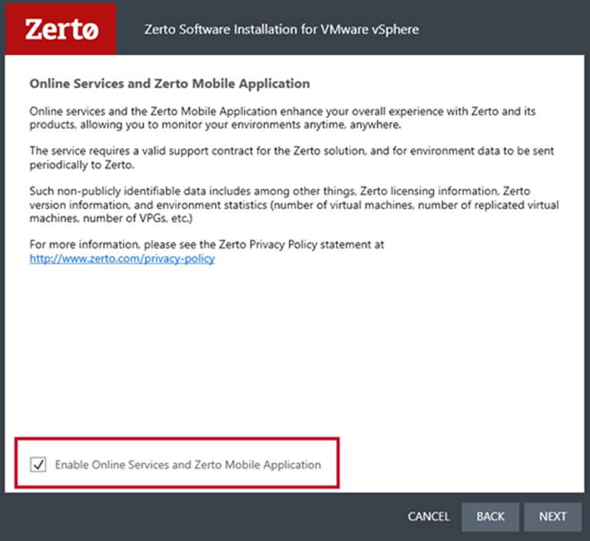

1. Setup the ZVM
   * Log in to ZVM and pair the site to your Cloud License, either via the ZCC (DRaaS) or the ZVM (ICDR).
   * In the ZVM’s settings, check again to ensure that the check box to opt-in to Zerto analytics is enabled.
   * Allow for at least 12 hours for data to fully populate the Planner tool.
2. Log in to Zerto Analytics and navigate to the "Planning" tab. Once there, left-click the button labelled “VM Selection”, seen below:

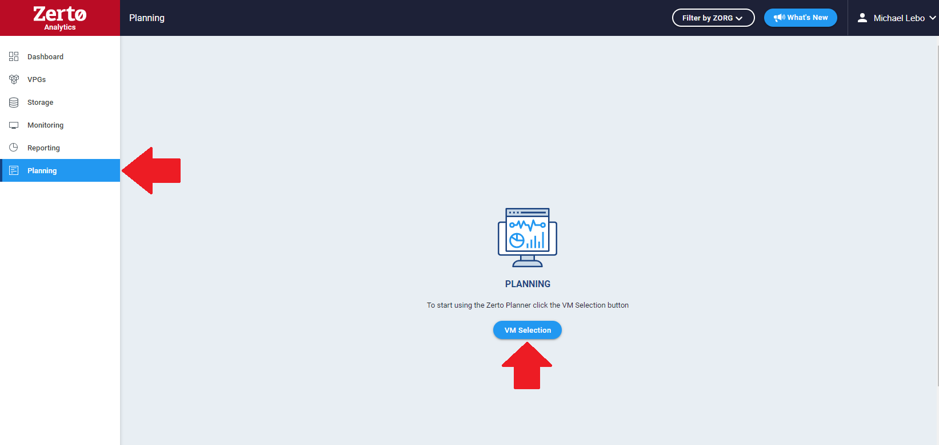

1. A new VM selection screen will pop-up within the Analytics. Once there, you will:
   * Select the desired Source Site
   * Select the desired target platform (Azure, AWS, On-prem)
   * Select the VMs that you wish to monitor from the left-hand panel. Use the arrows located in the center of the window to move the VMs to the right-hand panel for monitoring. Only these selected VMs will show in the planning report. Once completed, left-click the save button on the bottom-right corner:

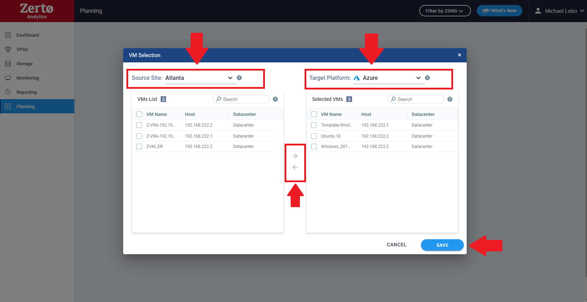

1. Once saved, the Planner will direct you to the generated report. Allow the Planner to monitor the VMs for an extended period by simply leaving the ZVM online for the desired timeframe (hours, days, or weeks). This will give a more accurate aggregate of the data for the Planner’s recommendations.



**Note:** Under the Journal History column, a detailed journal history adjustment can be made to specify the policy assigned to each VM. The calculated journal history limited is added to the total above.

Considerations:

* ZVM queries the hypervisor to track IO behavior of all the source VMs
* The collected data is securely transmitted to your Zerto Analytics page
* Data is analyzed and is delivered in Zerto Analytics “Planning” tab
  + Based on the measured IO patterns of the source VMs.
  + Assumes 50% compression ratio and 24 hours of journal history. This will be customizable in later versions of the tool.



**Note:** The external zPlanner tool option is still available, but it will require its requested use and training from your Zerto Cloud Architect. This option can be leverage if the end-user doesn’t want to initially implement the ZVM. It will still deploy a VM within their environment via an OVF template, and its sizing requirements will be the same resources as a ZVM’s requirements would be. Because of this, it is strongly encouraged that the customer deploys the ZVM and doesn’t use this option. If circumstances require this option or you would like to know more, please contact your Zerto Account team for more information.

Legacy Tools:

For ZVR 7.0 and below, Zerto’s original rendition of the journal and replication sizing tools was a combination of our “[WAN Sizing – Zerto Software](http://s3.amazonaws.com/zertodownload_docs/Latest/Using%20the%20Zerto%20WAN%20Sizing%20Estimator.pdf?cb=1563376543)” and our “[Journal Sizing Tools – Zerto Software](http://s3.amazonaws.com/zertodownload_docs/Latest/Zerto%20Journal%20Sizing%20Tools.zip)”. Both of which can still be found our Technical Documentation [page](https://www.zerto.com/myzerto/technical-documentation/). The WAN sizing tools are PowerShell scripts that can be setup to track specific VMs for a customized timeframe. Once the tool has ran for the allotted timeline, the output can be added into the Journal Sizing tools, which is a downloadable .zip file containing excel calculators. You can input the extracted change rate data into these calculators to get estimated journal sizing details. The tools contain their own how-to guides within the .zip file and PDF attached to each tool.

WAN Sizing – Zerto Software:

<http://s3.amazonaws.com/zertodownload_docs/Latest/Using%20the%20Zerto%20WAN%20Sizing%20Estimator.pdf?cb=1563376543>

## Zerto External SQL Database – Required for All Cloud Providers

Database Requirements

During the Zerto Virtual Manager installation, the user can select whether to install and use an embedded SQL Server (localdb) as the database.

Alternatively, and also during the installation, the user is able to choose whether to instead select and use an external SQLServer instance. To use an externally managed database, during the installation select the Custom Installation option.

The larger the environment protected by Zerto Virtual Manager, the larger the database size required to support it.

Supported Microsoft SQL Server versions: 2012, and higher.

Before installing Zerto Virtual Manager, click to thoroughly review the following guides:

* [Migrating the Zerto Database to Microsoft SQL Server.](http://s3.amazonaws.com/zertodownload_docs/Latest/Migrating%20the%20Zerto%20Virtual%20Replication%20Database%20to%20Microsoft%20SQL%20Server.pdf)
* [Zerto Scale and Benchmarking Guidelines.](http://s3.amazonaws.com/zertodownload_docs/Latest/Zerto%20Scale%20and%20Benchmarking%20Guidelines.pdf)

You must have the following permissions set:

* Public and dbcreator server roles.
* Permission to connect to the database engine.
* Login enabled.
* Within User Mapping choose the master

Cloud Service Providers will be required to always use an External SQL Database for their ZVMs that customers will replicate in to. The embedded SQL DB installed is capped at 10GBs and could easily be filled as a MSP scales with increasing customers and VMs in replication. If a MSP is not already on an external SQL DB, they will want to schedule a maintenance window to do so immediately. Below is Zerto’s most up to date guide on how to migrate your ZVM to an external SQL database.

Migrating the ZVM Database to SQL Server – Zerto Software

<http://s3.amazonaws.com/zertodownload_docs/Latest/Migrating%20the%20Zerto%20Virtual%20Replication%20Database%20to%20Microsoft%20SQL%20Server.pdf>

## Required Automated Billing Setup and Testing

A MSP’s billing model is based on their ability to connect their Zerto Virtual Managers to Zerto's billing server. In order to participate in Zerto’s Automated Billing model, the MSP must have a steady connection to Zerto's billing server. If the MSP is unable to connect to Zerto's billing server, they are manually billed based on usage data.

When the MSP is part of Zerto's Automated Billing program, unlike previous Zerto versions, they can no longer rely on the ZCM to report usage data. Instead of which, all of their Zerto Virtual Managers must maintain a steady connection to Zerto’s billing server. This can be done either:

* By connecting directly to Zerto’s Billing server, which is autologs.zerto.com over port 443.
* Or, by directing the connection via proxy server. For further guidelines on this, see [KB](https://www.zerto.com/myzerto/knowledge-base/zerto-csp-automated-billing-call-home/).

If there is any reason that this usage information is not sent, an urgent and persistent alert appears in Zerto Virtual Manager in the form of a banner. The alert also appears in Monitoring > Alerts. The alert informs the MSP that the Zerto Virtual Manager did not send its site usage information for billing purposes to Zerto’s servers; if the issue is not resolved within the specified days, the Zerto Virtual Manager will stop communicating with its VRAs.

When the alert appears in the ZVM banner, the MSP is strongly advised to click on the link to test the connection to Zerto’s servers.

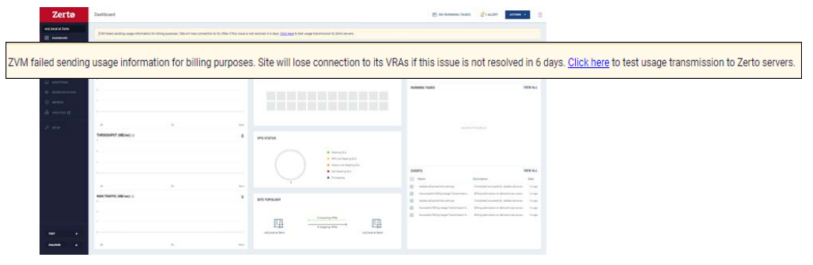

When the alert first appears, the MSP will have 15 days to resolve the issue, before the next alert appears. The next alert is the disconnection alert.

When the disconnection alert appears, the ZVM has already stopped communicating with its VRAs. The disconnection alert informs the MSP that the ZVM did not send its site usage information for billing purposes to Zerto’s servers, and that ZVM will not communicate with its VRAs until this issue is resolved.





**Note:** If a ZVM requires a high level of security (I.E. FIPS or equivalent regulations), please make sure to reach out to your Zerto account team to review our Dark Site licensing policy. This option will require a deep case review for the justification of the circumstances and will only be granted on a per case basis.

Manually Test Connection and Send Usage Data to Zerto Servers

To manually test the connection to Zerto’s servers, and also send usage data for billing purposes:

1. In the top right of the ZVM window, click the options icon.

2. Select License, then click TEST USAGE TRANSMISSION TO ZERTO.

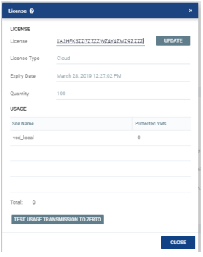

If a MSP’s internal protocols require that the usage is sent through a proxy, please see the article linked below:

Setting Up a Proxy with Zerto:

<https://www.zerto.com/myzerto/knowledge-base/setting-up-a-proxy-with-zerto/>

Supplemental Cloud Billing KB:

Zerto MSP Automated Billing (Call Home):

[https://www.zerto.com/myzerto/knowledge-base/zerto-MSP-automated-billing-call-home/](https://www.zerto.com/myzerto/knowledge-base/zerto-csp-automated-billing-call-home/)

**Note:** If a you have questions about your licensing agreement and the licenses that you currently have available, please contact your Zerto account team for further information.

Dark Site Licensing Model

If both the Production and DR environments require a high level of security (I.E. FIPS, FedRAMP, or equivalent regulations), where absolutely no internet access is allowed within the environment, then Dark Site Licensing may be required for Zerto replication. Dark Site licensing does not require Zerto’s automatic billing callhome and uses a manual billing process at the beginning of each month.

Please make sure to reach out to your Zerto account team to review our Dark Site licensing policy. This option will require a deep-dive case review for the specific circumstantial justification and will only be granted on a per case basis.

Please note that in many cases a [billing proxy](https://www.zerto.com/myzerto/knowledge-base/setting-up-a-proxy-with-zerto/) will be suggested instead. This proxy can be setup directly on the ZCM, if needed.

Requirements and Caveats:

* Dark Site licenses can ONLY pair with other Dark Sites. The license will block pairing with non-dark sites, as this will break the security requirements trying to be achieved via the Dark licensing. A billing proxy server would be required instead.
* Dark Site licenses have a “hard cap” on the total number of VMs that can be replicated. Unlike other Cloud production licenses which have a surpassable “soft cap” that is auto-billed on consumption, Dark Licenses can only replicate up to their set number.
* Licenses are created on shorter termed basis’s then other production licenses (3-6 months).
  + This is partially in line with the “hard cap” on the license. This helps to minimize the necessity to create overlapping licenses as new deals come to fruition, while also aiding the forecasting process.
* A manual billing cadence with your Zerto Account Team and Accounts Receivable must be setup for the beginning of each month (within first 6 days of each month). See below on how to gather the manual billing reports.

How to Gather Manual Billing Reports:

The MSP is required to deliver reports for all sites on which the Dark Site software was operated during the month. Here are the directions to get the usage report:

1. Access the ZVM required to generate the manual report
2. Click on the Reports tab
3. Use the Report selection dropdown to select the Usage Report from the list of possible reports
   * “Usage Report” is only an available option for ZVMs where a Cloud Production license is applied. End-customers ZVMs or others ZVMs with non-Cloud licenses (Enterprise) will not have this option.
4. Select the year and then the month for the report
5. Export the report to the desired output (CSV file is required for billing purposes)

## Platform Administration, Installation, and Documentation Guides

This informational section has the direct hyperlinks to Zerto’s key documentation for each of our supported platforms. They are the most up to date guides, covering everything from the initial deployment to the continuous management of the infrastructure.

Zerto Cloud Manager Set:

Cloud Service Provider Guidelines – Zerto Software

<http://s3.amazonaws.com/zertodownload_docs/Latest/Zerto%20Virtual%20Replication%20Cloud%20Service%20Provider%20Guidelines.pdf?cb=1562094588>

Installation Guide – Zerto Cloud Manager

<http://s3.amazonaws.com/zertodownload_docs/Latest/Zerto%20Cloud%20Manager%20Installation.pdf>

Administration Guide – Zerto Cloud Manager

<http://s3.amazonaws.com/zertodownload_docs/Latest/Zerto%20Cloud%20Manager%20Administration%20Guide.pdf?cb=1562094588>

HTML Version:

<http://s3.amazonaws.com/zertodownload_docs/Latest/Zerto%20Virtual%20Replication%20Zerto%20Cloud%20Manager%20(ZCM)%20Online%20Help/content/zerto_documentation_portal/homezcm.htm>

VMware Set:

vSphere Enterprise Guidelines – Zerto Software

<http://s3.amazonaws.com/zertodownload_docs/Latest/Zerto%20Virtual%20Replication%20vSphere%20Enterprise%20Guidelines.pdf>

VMware Installation Guide – Zerto Software <http://s3.amazonaws.com/zertodownload_docs/Latest/Zerto%20Virtual%20Replication%20Installation%20Guide%20for%20vSphere%20and%20Hyper-V.pdf>

vSphere Quick Start – Zerto Software

<http://s3.amazonaws.com/zertodownload_docs/Latest/Zerto%20Virtual%20Replication%20Quick%20Start%20with%20vSphere.pdf>

vSphere Administration Guide – Zerto Virtual Manager

<http://s3.amazonaws.com/zertodownload_docs/Latest/Zerto%20Virtual%20Manager%20vSphere%20Administration%20Guide.pdf>

HTML Version:

<http://s3.amazonaws.com/zertodownload_docs/Latest/Zerto%20Virtual%20Replication%20Zerto%20Virtual%20Manager%20%28ZVM%29%20-%20vSphere%20Online%20Help/index.htm?cb=1594479540>

Hyper-V Set:

Hyper-V Enterprise Guidelines – Zerto Software

<http://s3.amazonaws.com/zertodownload_docs/Latest/Zerto%20Virtual%20Replication%20Hyper-V%20Enterprise%20Guidelines.pdf>

Hyper-V Installation Guide – Zerto Software <http://s3.amazonaws.com/zertodownload_docs/Latest/Zerto%20Virtual%20Replication%20Installation%20Guide%20for%20vSphere%20and%20Hyper-V.pdf>

Hyper-V Quick Start – Zerto Software

<http://s3.amazonaws.com/zertodownload_docs/Latest/Zerto%20Virtual%20Replication%20Quick%20Start%20with%20Hyper-V.pdf>

Hyper-V Administration Guide – Zerto Virtual Manager

<http://s3.amazonaws.com/zertodownload_docs/Latest/Zerto%20Virtual%20Manager%20Hyper-V%20Administration%20Guide.pdf>

HTML Version: <http://s3.amazonaws.com/zertodownload_docs/Latest/Zerto%20Virtual%20Replication%20Zerto%20Virtual%20Manager%20%28ZVM%29%20-%20SCVMM%20Online%20Help/index.htm?cb=1594479540>

Azure Set:

Azure Enterprise Guidelines – Zerto Software

<http://s3.amazonaws.com/zertodownload_docs/Latest/Zerto%20Virtual%20Replication%20Azure%20Enterprise%20Guidelines.pdf?cb=1562094588>

Azure Installation Guide – Zerto Software

<http://s3.amazonaws.com/zertodownload_docs/Latest/Zerto%20Virtual%20Replication%20Installation%20Guide%20for%20Azure.pdf?cb=1562094588>

Azure Quick Start – Zerto Software

<http://s3.amazonaws.com/zertodownload_docs/Latest/Zerto%20Virtual%20Replication%20Quick%20Start%20with%20Azure.pdf?cb=1562094588>

Linux Virtual Machine Preparation Guide for Protecting Virtual Machines to Azure

https://s3.amazonaws.com/zertodownload_docs/Marketing_Material/Linux+Virtual+Machine+Azure+Configuration+Guide.pdf?cb=1594751348

VPN Solutions for Zerto to Azure – IPSec

http://s3.amazonaws.com/zertodownload_docs/Marketing_Material/VPN%20Solutions%20for%20Zerto%20to%20Azure%20-%20IPSec.pdf?cb=1594751348

VPN Solutions for Zerto to Azure – SoftEther

http://s3.amazonaws.com/zertodownload_docs/Marketing_Material/VPN%20Solutions%20for%20Zerto%20to%20Azure%20-%20SoftEther.pdf?cb=1594751348

Azure Administration Guide – Zerto Virtual Manager

<http://s3.amazonaws.com/zertodownload_docs/Latest/Zerto%20Virtual%20Manager%20Azure%20Administration%20Guide.pdf?cb=1562094588>

HTML Version:

<http://s3.amazonaws.com/zertodownload_docs/Latest/Zerto%20Virtual%20Replication%20Zerto%20Virtual%20Manager%20%28ZVM%29%20-%20Azure%20Online%20Help/index.htm?cb=1594479540>

AWS Set:

AWS Enterprise Guidelines – Zerto Software

<http://s3.amazonaws.com/zertodownload_docs/Latest/Zerto%20Virtual%20Replication%20AWS%20Enterprise%20Guidelines.pdf?cb=1562094588>

AWS Installation Guide – Zerto Software

<http://s3.amazonaws.com/zertodownload_docs/Latest/Zerto%20Virtual%20Replication%20Installation%20Guide%20for%20AWS.pdf?cb=1562094588>

AWS Quick Start – Zerto Software

<http://s3.amazonaws.com/zertodownload_docs/Latest/Zerto%20Virtual%20Replication%20Quick%20Start%20with%20AWS.pdf?cb=1562094588>

AWS Administration Guide – Zerto Virtual Manager

<http://s3.amazonaws.com/zertodownload_docs/Latest/Zerto%20Virtual%20Manager%20AWS%20Administration%20Guide.pdf?cb=1562094588>

HTML Version:

<http://s3.amazonaws.com/zertodownload_docs/Latest/Zerto%20Virtual%20Replication%20Zerto%20Virtual%20Manager%20%28ZVM%29%20-%20AWS%20Online%20Help/index.htm?cb=1594479540>

## Automation Documentation

If an MSP is looking to leverage REST APIs or PowerShell script for incorporating automation within their Zerto environment, please see the latest documentation listed below:

REST API Reference Guide – Zerto Software

<http://s3.amazonaws.com/zertodownload_docs/Latest/Zerto%20Virtual%20Replication%20RESTful%20APIs.pdf>

PowerShell Cmdlets Guide – Zerto Software

<http://s3.amazonaws.com/zertodownload_docs/Latest/Zerto%20Virtual%20Replication%20PowerShell%20Cmdlets%20Guide.pdf>

REST API Reference Guide – Zerto Cloud Manager

<http://s3.amazonaws.com/zertodownload_docs/Latest/Zerto%20Cloud%20Manager%20RESTful%20APIs.pdf>

Orchestrator for Automated Failover Testing – Zerto Software

<http://s3.amazonaws.com/zertodownload_docs/Latest/Automated%20Failover%20Testing%20with%20the%20Zerto%20Orchestrator.pdf>

Zerto Analytics APIs

<https://docs.api.zerto.com/>

## Provider Best Practices

As Zerto’s product evolves over time, so will its best practices. In this section, you will find the current and most basic best practice information. If you would like more best practices, please contact your Zerto account team and speak directly with your current Zerto Cloud Architect.

Extending Zerto’s Log Files Retention – Best Practice

The Zerto Virtual Manager (ZVM) retains standard-level log files according to the value set in the logging configuration file. By default, a maximum of 150 log files with a size of 10 MB each is retained, which equals approx. 72 hours of logging information. Once 150 standard-level log files have been created, the ZVM begins to remove the oldest log file as each new log file is created. Meanwhile, the Virtual Replication Appliance (VRA) retains a maximum of 1000 standard level log files by default on the VRA VM. Each file is a maximum of 1 MB in size, which also equals approx. 72 hours of logging information. The more logs that are retained, the further back in time Zerto’ Support can analyze.

Since logging is dependent on the rate that the information is being written to the file at, the timeframe covered by the logs may vary. Cloud Service Providers have large and continuously growing environments by nature. This means that the timeline covered by the logs will likely be lower than 72hrs and will continue to decrease as the Zerto infrastructure scales with an increasing number of paired sites and VPGs.

As more information is being recorded to the logs while scaling, the 10 MB size constraint is reached at an increasingly faster rate. To ensure that the log timeline is upheld in the event that thorough analysis is required, it is highly recommended that all Cloud Providers take the time to extend Zerto’s log retention.

Below is a direct link to our step-by-step guide for extending Zerto’s log retention:

[http://s3.amazonaws.com/zertodownload_docs/Latest/Extending%20Zerto%27s%20Log%20Files%](http://s3.amazonaws.com/zertodownload_docs/Latest/Extending%20Zerto%27s%20Log%20Files%20Retention.pdf)20Retention.pdf

Log Archiver – Supplemental best practice to extending log retention

Additionally, Zerto’s Log Archiver allows the user to offload the ZVM/VRA logs for remote storage. This can also be leveraged to retain the ZVM and VRA logs further, if it is deemed necessary:

[http://s3.amazonaws.com/zertodownload_docs/Latest/Zerto%20Virtual%20Replication%20Log%20Ar](http://s3.amazonaws.com/zertodownload_docs/Latest/Zerto%20Virtual%20Replication%20Log%20Archiver.pdf?cb=1562772396)chiver.pdf?cb=1562772396

#### Remote Log Collection (RLC)

Remote Log Collection allows customers to authorize Zerto support engineers to collect logs from their environment. By using remote log collection customers can avoid having to use the Diagnostic Tool on their ZVM server in order to collect logs for analysis, a potentially complex and time-consuming procedure.

To enable Remote Log Collection:

1. In the Zerto User Interface, click **SETTING** in the top right of the header and select Remote Support.

The Remote Support dialog is displayed.

1. Click the drop-down menu to display the remote log collection options.
2. Select the remote log collection option you wish to allow:

* **Never:** Remote log collection is not allowed (default). If remote log collection is currently allowed, the remote connection will be terminated if you select this option.
* **For the next 30 days:** Remote log collection is allowed. This permission will automatically terminate in 30 days unless terminated by selecting the **Never** option.
* **Only for the duration of a specific case:** You will be prompted to select the Case number from the drop-down list. The list contains all the active cases opened under the account that the Zerto Virtual Manager is registered to.

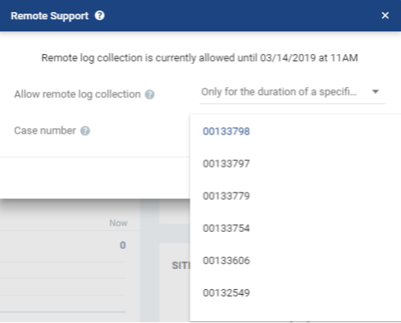

Remote log collection will be allowed for as long as the case is active or until remote log collection is terminated by selecting the Never option.

1. Click Save.

RLC Security

Outbound Connection: All I/O traffic is “requested” by Zerto and the ZVM pushes the logs to our log server(s). There are NO inbound connections via this feature.

Connection automatically terminates based on your previous selection:

You’re given several options when enabling RLC as noted below.

1. For 30 days.
2. Per case. If open on a per case basis, once the case has been closed by a Zerto Support Engineer, the connection will then be closed and would need to be re-enabled if needed in the future.

Limited Access: Remote Log Collection only allows the Support Engineer to gather logs and nothing else.

Transfer using HTTPS: Logs are transferred from the ZVM to a repository owned by Zerto.

The following ports need to be open for RLC to function:

Internally (to localhost) - 80, 9000  
Externally (to our servers) - 443

The following servers need to be accessible for the RLC to work:

[zsa.zerto.com](http://zsa.zerto.com/)

[cicredential.zerto.com](http://cicredential.zerto.com/)

[zlg-us.zerto.com](http://zlg-us.zerto.com/)

[zlg-emea.zerto.com](http://zlg-emea.zerto.com/)

Further Best Practices Documentation:

Security and Hardening – Zerto Software

<http://s3.amazonaws.com/zertodownload_docs/Latest/Security%20and%20Hardening%20with%20Zerto%20Virtual%20Replication.pdf>

Protecting Microsoft SQL Server with Zerto – Best Practices Guide

[http://s3.amazonaws.com/zertodownload_docs/Latest/SQLBestPractices.pdf?cb=156209](http://s3.amazonaws.com/zertodownload_docs/Latest/SQLBestPractices.pdf?cb=1562096717)6717

Oracle Best Practices – Zerto Software

[http://s3.amazonaws.com/zertodownload_docs/Latest/Zerto%20Virtual%20Replication%20and](http://s3.amazonaws.com/zertodownload_docs/Latest/Zerto%20Virtual%20Replication%20and%20Oracle%20Best%20Practices.pdf)%20Oracle%20Best%20Practices.pdf

Zerto Environment with VSS – Deployment and User Guide

https://s3.amazonaws.com/zertodownload_docs/Latest/VSS+Deployment+and+User+Guide.pdf?cb=1594751348

PCI DSS Compliance and Zerto – Zerto Software

http://s3.amazonaws.com/zertodownload_docs/Latest/Payment%20Card%20Industry%20Data%20Security%20Standard%20%28PCI%20DSS%29%20Compliance%20and%20Zerto.pdf?cb=1594753346

Exchange Best Practices

Please note that Zerto’s software protects your data at a VM level. There are not any Zerto specific best practices when protecting Exchange. Please adhere to Microsoft’s best practices for Exchange and/or Office 365.

## Upgrading the Zerto Infrastructure

As an MSP, you can upgrade your environment and customers manually or remotely. If the end-customer is on ZVR 6.0 or beyond, an MSP can perform remote upgrades by leveraging the Cloud Control section of myZerto.com (login required). Cloud Control was designed to help alleviate the obstacles often encountered when making change requests for customers. This section details the process to execute both manual and remote upgrades.

Before upgrading, make sure to review Zerto’s latest documentation on the version’s currently supported software, host versions, hypervisors, and more. All of this can be found within the Zerto Interoperability Matrix:

Interoperability Matrix for Zerto Environments

<http://s3.amazonaws.com/zertodownload_docs/Latest/Zerto%20Virtual%20Replication%20Operability%20Matrix.pdf>

To review a version’s newly added features, fixes, and more, please ensure that you read the latest release note documentation:

Release Notes – Zerto Software

<http://s3.amazonaws.com/zertodownload_docs/Latest/Zerto%20Virtual%20Replication%20Release%20Notes.pdf?cb=1562877641>

Once a decision has been made to upgrade the Zerto infrastructure, make sure to follow the latest version of our upgrade guide. This document includes step-by-step instructions on how to upgrade both the MSP and customer environments, along with the most current best practices for its execution:

Upgrading Zerto Virtual Replication – Zerto Virtual Replication

<http://s3.amazonaws.com/zertodownload_docs/Latest/Upgrading%20Zerto%20Virtual%20Replication.pdf>

Important: If you need to safeguard the ZVMs during an upgrade (I.E. the MSP ZVMs or critical end-customers) to ensure that the environment could be rebuilt if an issue occurs, navigate to the Zerto console as well as the GUI interface to perform these proactive configuration exports:

* In Zerto GUI: Export VPG Settings
* In Zerto GUI: Export VRA Settings
* In ZVM console, Open Zerto Diagnostics tool, Export the VPG Settings
* Extract hypervisor level IDs of VMs and correlate with the names (using for pre-seeding if necessary)
* Download the latest software release from myZerto.com

Key takeaways:

For environments using the Zerto Cloud Manager:

* Upgrade the Zerto Cloud Manager before upgrading the Zerto Virtual Managers.
* Zerto Cloud Manager (ZCM) supports Zerto Virtual Manager (ZVM) of N and N-1 versions.

**For Example:** ZCM of version 8.0 supports ZVMs of versions 8.0, 7.5 and their updates.

* You can upgrade Zerto Virtual Managers from version N to the next version (N+1) of Zerto, including to any update within the current version. You cannot do an N+2 upgrade directly.

**For Example:** Zerto Virtual Manager of version 7.5 is compatible with ZVMs of versions 8.0, 7.0 and their updates.

* A Zerto Virtual Manager can be used with a different ZVM version on another site, if the other version is only one version higher or lower.

To understand further, please reference the chart below:

|  |  |  |
| --- | --- | --- |
| Version (N-1) | Current Version (N) | Version (N+1) |
| 6.0, 6.0Ux | 6.5, 6.5Ux | 7.0, 7.0Ux |
| 6.5, 6.5Ux | 7.0, 7.0Ux | 7.5, 7.5Ux |
| 7.0, 7.0Ux | 7.5, 7.5Ux | 8.0, 8.0Ux |

* Make sure that all VPGs are in the state **Protecting**, and not in a sync state, such as Delta Sync, or in an error state, such as Needs Configuration.
* **Complete** any recovery operation before starting the upgrade.
* The port 9071 needs to be opened for the version 8.0 between sites. The port 9081 for sites 7.5 to 8.0, TCP communication between ZVMs and between a customer ZVM and a Zerto Cloud Connector, maintained for backward compatibility purposes.
* When upgrading the MSP ZVMs, create a backup of the machine where the Zerto Virtual Manager runs, which can be used if the upgrade fails. Zerto recommends taking a snapshot of the machine after stopping the Zerto Virtual Manager service.



**Note:** The snapshot should only be used to roll back to the pre-upgrade state immediately after the upgrade has completed. The snapshot should not be used after the protection of virtual machines has restarted.

Navigate to the Zerto console, as well as the GUI interface of Zerto to perform proactive configuration exports in case of an incident:

* In Zerto GUI: Export VPG Settings
* In Zerto GUI: Export VRA Settings
* In ZVM console, Open Zerto Diagnostics tool, Export the VPG Settings
* Extract hypervisor level IDs of VMs and correlate with the names (using for pre-seeding if necessary)
* Download the latest software release from myZerto.com

Cloud Control Remote Upgrades

As of ZVR 6.0, Zerto added the ability to remotely upgrade the ZVMs from the Zerto SaaS platform. If you and your customers are on **ZVR 6.0 or higher**, then you will be able to leverage the Upgrade Manager of the myZerto.com Cloud Control section.

Requirements: The ZVM must have “Enable Zerto SaaS Features” enabled under the “About” section of Zerto site settings and the ZVM must have port 443 open to <https://zerto-mobile-data.zerto.com>:

http://s3.amazonaws.com/zertodownload_docs/Latest/Zerto%20Virtual%20Replication%20Zerto%20Virtual%20Manager%20%28ZVM%29%20-%20vSphere%20Online%20Help/AdministratorforZertoVirtualManager/images/About_Cloud.png

Remote Upgrade Process:

1. Log into the myZerto.com and navigate to the Cloud Control tab:

1. Under the Cloud Control section, navigate to the Upgrade Manager tab. The ZVM sites within the Upgrade Manager will only be ZVMs leveraging your account’s licensure. This will include all your ZVMs and any customer ZVMs. The Upgrade Manager will also provide basic information about the ZVMs, including the current version, site-to-site pairing, ZORG name, and more. Select the site that you would like to upgrade by checking the box to the left of the ZORG name, and then selecting the “Remote Upgrade” option on the top left:

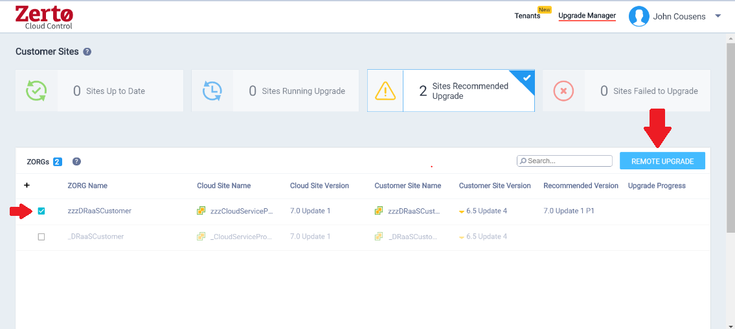

1. Once the Remote Upgrade option has been selected, a pop-up screen will appear to confirm the continuation of the request. This screen will also alert the user that the VRAs will be queued for upgrade once the ZVM finishes:

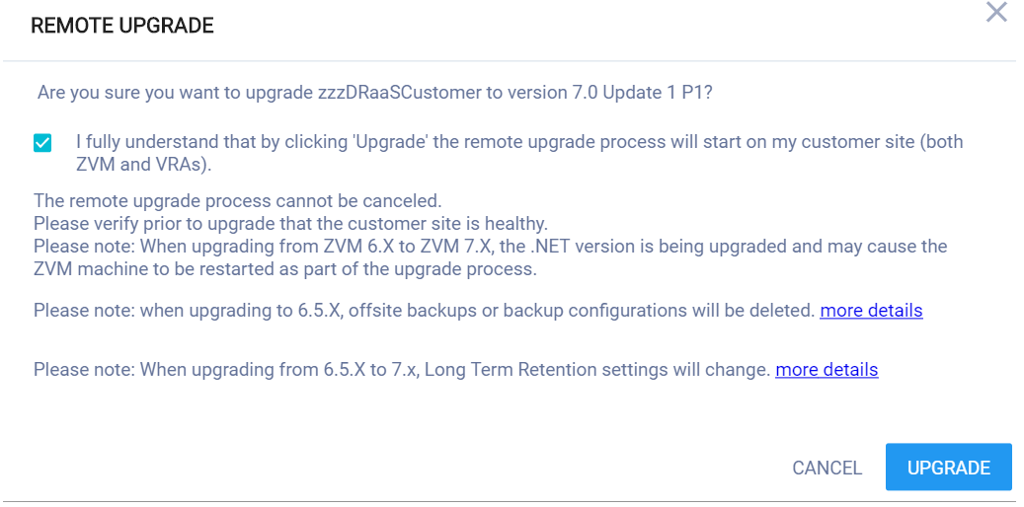

1. The remote ZVM will reach out to Zerto’s repository for the upgrade executable, download the files, and proceed with the upgrade on the ZVM. Once finished, the Upgrade Manager will alert the user with verbiage of its completion:

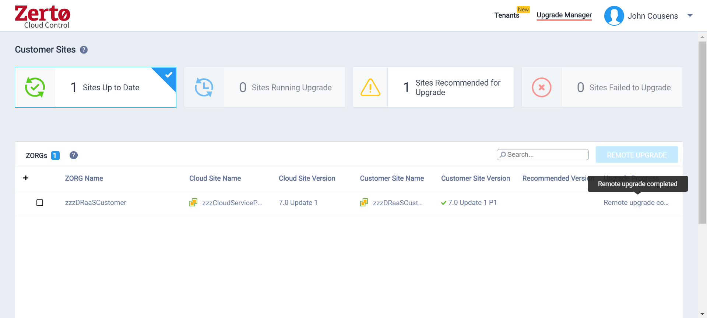

Cloud Provider Deployment information

Zerto Network Requirements - Cloud

Site-to-site networking:

See *Networking*/*VPN Worksheet* – This is in place in case your Network Admin or VPN standardization for customer deployments has any specifics that need to be acknowledged.

Zerto Port Requirements for MSP Environments (# represents the item on the following diagrams):

|  |  |  |
| --- | --- | --- |
| Port | # | Purpose |
| 22 | **9, 24** | During Virtual Replication Appliance (VRA) installation on ESXi 4.x and 5.x hosts for  communication between the Zerto Virtual Manager (ZVM) and the ESXi hosts IPs and  for ongoing communication between the ZVM in the cloud site – but not the customer  site – and a Zerto Cloud Connector. |
| 443 | **2, 6, 8, 19** | During VRA installation on ESX/ESXi hosts for communication between the ZVM and  the ESX/ESXi hosts IPs and for ongoing communication between the ZVM and vCenter  Server and vCloud Director. |
| 4005 | **10** | Log collection between the ZVM and site VRAs. |
| 4006 | **11** | TCP communication between the ZVM and local site VRAs and the site VBA. |
| 4007 | **16, 21** | TCP control communication between protecting and peer VRAs. |
| 4008 | **17, 25** | TCP communication between VRAs to pass data from protected virtual machines to a VRA on a recovery site. |
| 4009 | **12** | TCP communication between the ZVM and local site VRAs to handle checkpoints. |
| 5672 | **20** | TCP communication between the ZVM and vCloud Director for access to AMQP messaging. |
| 7073 |  | Internal port, used only on the ZVM VM. Used for communication with the service in charge of collecting data for the Zerto Resource Planner.  **Note :** Unless you select the checkbox ‘Enable Support notification and product improvement feedback’, data is not transmitted to Zerto Analytics. |
| 8100 | **-** | Communication between the Zerto Virtual Manager and the System Center Virtual Machine Manager in a customer site running Zerto Virtual Replication with Hyper-V. |
| 9071* |  | HTTPS communication between paired ZVMs, when both Zerto versions are 8.0 and above. |
| 9080* | **1, 13, 15, 18** | • HTTP communication between the ZVM and Zerto internal APIs, a Zerto Cloud  Manager (ZCM), cmdlets, which should only be available to a customer using  DRaaS and not ICDR.  • HTTP communication between ZVM and Zerto Cloud Manager (ZCM). When the  customer's ZCM is **v5.5 and above**, and their ZVM is **v5.0**, communication is via  this port. |
| 9081* | **7, 23, 27** | TCP communication between ZVMs and between a customer ZVM and a Zerto Cloud Connector, maintained for backward compatibility purposes.  **This port must not be changed when providing DRaaS.** |
| 9082 and up | **22, 26, 28, 29** | Two ports for each VRA (one for port 4007 and one for port 4008) accessed via the  Zerto Cloud Connector installed by the cloud service provider. There is directionality  to these ports. Use a port range starting with port 9082. For example, Customer A  network has 3 VRAs and customer B network has 2 VRAs and the cloud service  provider management network has 4 VRAs, then the following ports must be open in  the firewall for each cloud: The cloud service provider's VRAs need to use 6 ports to  reach customer A's VRAs, while customer A's VRAs need 8 ports to reach the cloud's  VRAs. The cloud service provider's VRAs need to use 4 ports to reach customer B's  VRAs, while customer B's VRAs need 8 ports to reach the cloud's VRAs |
| 9180* | **32** | Communication between the ZVM and the VBA. |
| 9669* | **3, 4, 5, 14** | HTTPS communication between:  • Machines running Zerto User Interface and Zerto Virtual Manager  • Zerto Virtual Manager and Zerto REST APIs  • ZVM and Zerto Cloud Manager (ZCM). When the customer's ZCM and ZVM are both  **v5.5 and above**, communication is via this port. |
| 9779 |  | HTTPS communication between the Zerto Self-Service Portal for in-cloud (ICDR)  customers and a ZVM. |
| 9989 |  | HTTPS communication between the browser and the Zerto Cloud Manager. |

**\*The default port provided during the ZVR installation which can be changed during the installation.**

**\*\*When the same vCenter Server is used for both the protected and recovery sites, ZVR is installed on one site only and this port can be ignored**

DRaaS Architecture Diagram: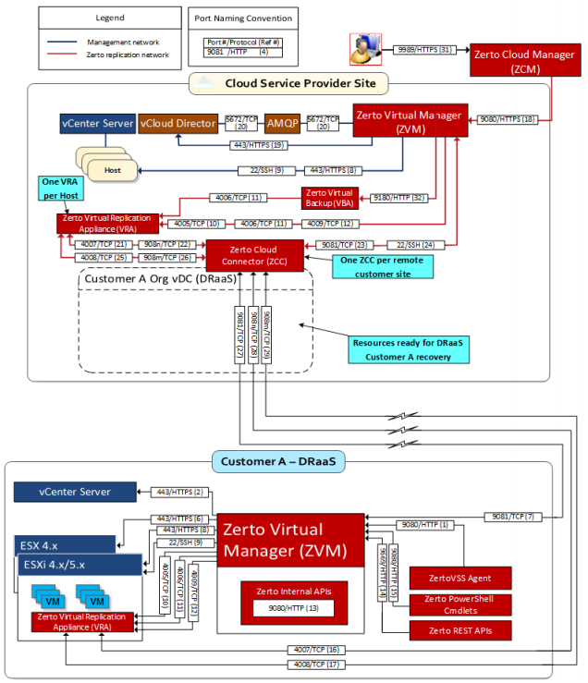

ICDR Architecture Diagram: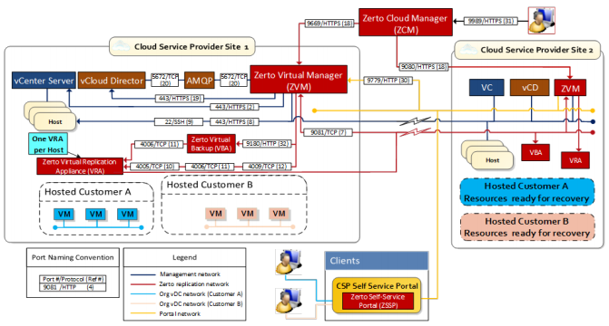

For the most current Zerto port requirements, please see our guideline documentation here:

Enterprise ZVM requirement (For your end-customers):

<http://s3.amazonaws.com/zertodownload_docs/Latest/Zerto%20Virtual%20Replication%20vSphere%20Enterprise%20Guidelines.pdf>

Cloud ZCM requirements (For the MSP environment and added components):

<http://s3.amazonaws.com/zertodownload_docs/Latest/Zerto%20Virtual%20Replication%20Cloud%20Service%20Provider%20Guidelines.pdf?cb=1562948746>

Zerto Cloud Connector (ZCC) Deployment and Networking Configuration

A common obstacle of Cloud deployments is the ZCC implementation and its connectivity between the customer and target environment. Below is a more in-depth review of the ZCC deployment for your new customers. This is directly from our guidelines, which is linked throughout this documentation. As always, make sure to review our latest documentation to ensure that deployments are always following current requirements.

Defining DRaaS Components

In a DRaaS configuration, the organization networks for disaster recovery are extended to the cloud. Zerto Cloud Connectors (ZCC) are installed to ensure that these networks have no touch points with the cloud infrastructure network, providing complete network separation between each organization network and the cloud service provider infrastructure network. All the traffic to and from the organization is routed through the cloud connector, so that the following is implemented:

* None of the organizations have direct access to the cloud service provider network and cannot see any part of the cloud service provider network that the cloud service provider does not allow them to see.
* Each organization has no access to the network of another organization.

A ZCC is a virtual machine installed on the cloud side, one for each customer organization replication network. The ZCC requires both cloud-facing and customer-facing static IP addresses. Also, for the cloud connector, the IP ranges used for the organization network and cloud service provider infrastructure network cannot be the same. The cloud connector requires the following:

* 4GB disk space
* At least 1GB of reserved memory.
* 1 vCPU.

Zerto recommends using a 10Gbps NIC for each Zerto Cloud Connector, enabling it to handle 10Gbps of traffic.

The ZCC routes traffic between the customer network and the cloud replication network, in a secure manner ensuring complete separation between the customer network and the cloud service provider network.

The ZCC has two Ethernet interfaces, one to the customer’s network and one to the cloud service provider's network. Within the cloud connector a bidirectional connection is created between the customer and cloud service provider networks. Thus, all network traffic passes through the ZCC, where the incoming traffic on the customer network is automatically configured to IP addresses of the cloud service provider network.

If the cloud service provider wants to institute additional security when using a ZCC, it can define a static route that will hop to a different cloud network, specifically for use by the Zerto Virtual Manager and VRAs in the cloud site.



**Note:**If you change the Zerto Virtual Manager and VRAs cloud network, changing the static route settings for a group to the new network only changes the access for new ZCCs with the specified group. Existing ZCCs must be redeployed to use the changed static route.

ZCCs are defined per organization with one ZCC defined for each organization site. Each ZCC requires two ports for each VRA (one port for VRA port 4007 and one port for port 4008) accessed via the ZCC. There is directionality to these ports.

For example, Customer A network has three VRAs and customer B network has two VRAs and the cloud service provider network has four VRAs, then the following ports must be open in the firewall: The cloud service provider’s VRAs need to use six ports to reach customer A’s VRAs, while customer A’s VRAs need eight ports to reach the cloud’s VRAs. The cloud service provider’s VRAs need to use four ports to reach customer B’s VRAs, while customer B’s VRAs need eight ports to reach the cloud’s VRAs.

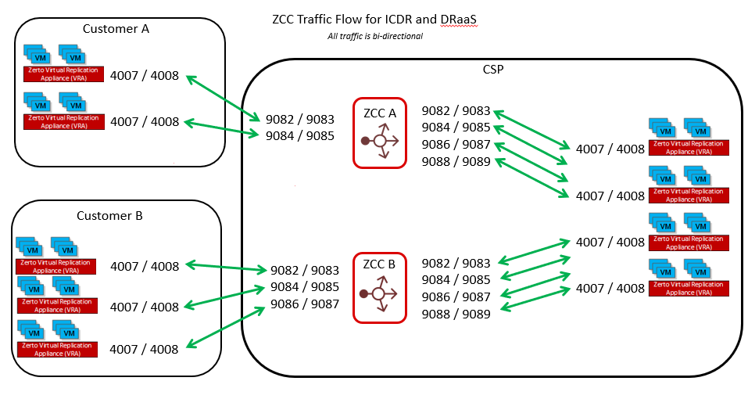

Customer A (CA) to Cloud Service Provider (MSP) VRAs via ZCC1:

ZCC1_CA:9082, ZCC1_CA:9083 > VRA_MSP_1:4007, VRA_MSP_1:4008  
ZCC1_CA:9084, ZCC1_CA:9085 > VRA_MSP_2:4007, VRA_MSP_2:4008  
ZCC1_CA:9086, ZCC1_CA:9087 > VRA_MSP_3:4007, VRA_MSP_3:4008  
ZCC1_CA:9088, ZCC1_CA:9089 > VRA_MSP_4:4007, VRA_MSP_4:4008

Customer B (CB) to Cloud Service Provider (MSP) VRAs via ZCC2:

ZCC2_CB:9082, ZCC2_CB:9083 > VRA_MSP_1:4007, VRA_MSP_1:4008  
ZCC2_CB:9084, ZCC2_CB:9085 > VRA_MSP_2:4007, VRA_MSP_2:4008  
ZCC2_CB:9086, ZCC2_CB:9087 > VRA_MSP_3:4007, VRA_MSP_3:4008  
ZCC2_CB:9088, ZCC2_CB:9089 > VRA_MSP_4:4007, VRA_MSP_4:4008

Cloud Service Provider (MSP) VRAs to customer VRAs:

ZCC1_MSP:9082, ZCC_CA:9083 > VRA_CA_1:4007, VRA_CA_1:4008  
ZCC1_MSP:9084, ZCC_CA:9085 > VRA_CA_2:4007, VRA_CA_2:4008  
ZCC1_MSP:9086, ZCC_CA:9087 > VRA_CA_3:4007, VRA_CA_3:4008  
ZCC2_MSP:9082, ZCC_CB:9083 > VRA_CB_1:4007, VRA_CB_1:4008  
ZCC2_MSP:9084, ZCC_CB:9085 > VRA_CB_2:4007, VRA_CB_2:4008



**Note:**If a VRA is uninstalled, connectivity from that VRA to any ZCC is lost. After a VRA is reinstalled on the host, the ports that were used for the connection to the ZCC are not reused and new ports must be opened in the firewall for the cloud site.

Adding a Cloud Connector for a Site

A cloud connector requires 4GB disk space, at least 1GB of reserved memory, and 1 vCPU.

**To add a cloud connector for a site:**

**1.** Click a ZORG in the Zerto Cloud Manager Organizations tab or select the row in the display and then click EDIT.

**2.** Select the Customer Sites tab.

**3.** Click ADD.

The Install Cloud Connector dialog is displayed.

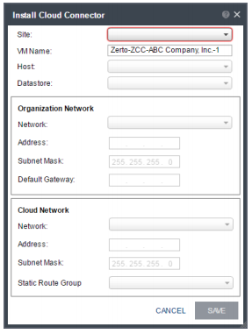

Specify the following:

* Site: The site used by the cloud service provider for the organization.
* VM Name: The name to assign to the cloud connector virtual machine.
* Host: The recovery host for the cloud connector virtual machine. The dropdown displays the hosts which do not have a cloud connector installed.
* Datastore: The datastore for the cloud connector virtual machine.

**Organization Network: The customer network details:**

* Network: The name of the customer’s network.
* Address: The IP address used to access the organization network. The customer pairs to this IP address.
* Subnet Mask: The subnet mask for the customer network. The default value is 255.255.255.0.
* Default Gateway: The default gateway for the customer network.

**Cloud Network: The cloud service provider local network details:**

* Network: The name of the cloud-side network.
* Address: The IP address to access the cloud service provider network that communicates with the cloud
* connector.
* Subnet Mask: The subnet mask for the cloud service provider network. The default value is 255.255.255.0.
* Static Route Group: The name of the group for which static routes are defined to the Zerto Virtual Manager network and VRA network. If a static route group is not specified, it is assumed that the Zerto Virtual Manager and VRAs are on the same network.

**4.** Click SAVE.

The cloud connector installation starts, and the status is displayed in the table.

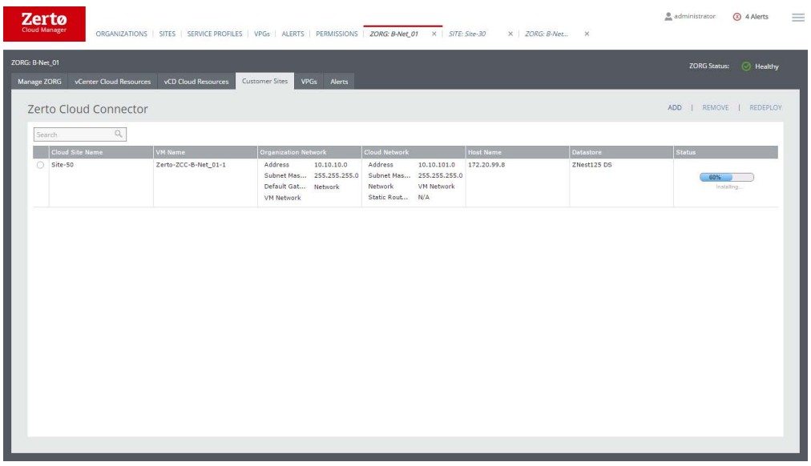

## Internal Zerto Infrastructure Details

This section is designed to document the MSP’s internal Zerto infrastructure. It will ensure that if your current Zerto administrator is unavailable for any reason, the next employee with have all the information fully documented for troubleshooting or review.

#### VCenter/vCD Server Details – Location #1

|  |  |
| --- | --- |
| Host Name/IP |  |
| vCenter/vCD Version and Build |  |
| Zerto Service Administrative User |  |
| Site Name |  |
| VMware HA enabled | Not used |

#### Zerto Virtual Manager Configuration and Deployment – Location #1

|  |  |
| --- | --- |
| ZVM Name |  |
| Site Location |  |
| VM ZVM is deployed on | VM name |
| ZVM Version | 8.0u3 |
| ZVM Static IP |  |
| Gateway |  |
| DNS |  |
| Windows Server Version |  |
| Virus scan exclusions: C:\Program Files (x86)\Zerto\Zerto Virtual Replication | Yes/No |
| vCPU | 2 |
| Memory | 4GB |
| NTP configured | Yes/No |
| Other applications installed on this VM | Yes/No – The answer should ALWAYS be No. This field is to help ensure that |
| Contact Email |  |
| Contact Phone |  |

#### VRA Information – Location #1

|  |  |
| --- | --- |
| VRA ESXi Host | Static IP |
|  |  |
|  |  |
|  |  |
|  |  |
|  |  |
|  |  |
|  |  |
|  |  |
|  |  |
|  |  |

#### VCenter/vCD Server Details – Location #2

|  |  |
| --- | --- |
| Host Name/IP |  |
| vCenter/vCD Version and Build |  |
| Zerto Service Administrative User |  |
| Site Name |  |
| VMware HA enabled | Not used |

#### Zerto Virtual Manager Configuration and Deployment – Location #2

|  |  |
| --- | --- |
| ZVM Name |  |
| Site Location |  |
| VM ZVM is deployed on | VM name |
| ZVM Version | 8.0u3 |
| ZVM Static IP |  |
| Gateway |  |
| DNS |  |
| Windows Server Version |  |
| Virus scan exclusions: C:\Program Files (x86)\Zerto\Zerto Virtual Replication | Yes/No |
| vCPU | 2 |
| Memory | 4GB |
| NTP configured | Yes/No |
| Other applications installed on this VM | Yes/No – The answer should ALWAYS be No. This field is to help ensure that |
| Contact Email |  |
| Contact Phone |  |

#### VRA Information – Location #2

|  |  |
| --- | --- |
| VRA ESXi Host | Static IP |
|  |  |
|  |  |
|  |  |
|  |  |
|  |  |
|  |  |
|  |  |
|  |  |
|  |  |
|  |  |

#### VCenter/vCD Server Details – Location #3

|  |  |
| --- | --- |
| Host Name/IP |  |
| vCenter/vCD Version and Build |  |
| Zerto Service Administrative User |  |
| Site Name |  |
| VMware HA enabled | Not used |

#### Zerto Virtual Manager Configuration and Deployment – Location #3

|  |  |
| --- | --- |
| ZVM Name |  |
| Site Location |  |
| VM ZVM is deployed on | VM name |
| ZVM Version | 8.0u3 |
| ZVM Static IP |  |
| Gateway |  |
| DNS |  |
| Windows Server Version |  |
| Virus scan exclusions: C:\Program Files (x86)\Zerto\Zerto Virtual Replication | Yes/No |
| vCPU | 2 |
| Memory | 4GB |
| NTP configured | Yes/No |
| Other applications installed on this VM | Yes/No – The answer should ALWAYS be No. This field is to help ensure that |
| Contact Email |  |
| Contact Phone |  |

#### VRA Information – Location #3

|  |  |
| --- | --- |
| VRA ESXi Host | Static IP |
|  |  |
|  |  |
|  |  |
|  |  |
|  |  |
|  |  |
|  |  |
|  |  |
|  |  |
|  |  |

#### Multi-Site Pairing

This section is designed to help map out each site-to-site pairing within your internal MSP infrastructure.

ZVM Location #1

|  |  |
| --- | --- |
| Site Name |  |
| Site Location |  |
| Sites Paired With |  |

ZVM Location #2

|  |  |
| --- | --- |
| Site Name |  |
| Site Location |  |
| Sites Paired With |  |

ZVM Location #3

|  |  |
| --- | --- |
| Site Name |  |
| Site Location |  |
| Sites Paired With |  |

#### Zerto Throttling

If Zerto replication does not use a dedicated network, then throttling may be required during specific application tasks or other reasons. If applicable, please fill in the details below:

|  |  |  |  |
| --- | --- | --- | --- |
| Site Name | Site Throttling Occurs Between (*if applicable) | Throttle Timeframe | Details |
| Dallas vCenter | Boston vCD | 5AM to 8PM Su-Sa | 200Mbps |
| Boston vCD | Dallas vCenter | 8PM to 5AM Su-Sa | 250Mbps |

Accessing Recovery Tools

Network access

All recovery tools will require access to the corporate network. If access to a corporate network drop is unavailable, access is available via the following methods:

|  |  |  |  |
| --- | --- | --- | --- |
| Name | Type | Details | Site |
| Boston VPN | Cisco SSL VPN | Use a browser or the Cisco SSL client and point to https://bos-vpn.mycompany.com | Boston DR Colo |
| RDP Jump Host | MS RDP | Use Microsoft RDP Client and point to 1.2.3.4 port 33389 | Chicago Warehouse |
| Zerto ZSSP | Service Portal | <https://ZVM-IP:9779>  ZORG: TEST-ZORG  User: TESTER  Password: XXXXXX | Change Me |

Zerto Access

Zerto uses a web-based console that can be accessed via any device attached to the corporate network. The following Zerto Virtual Manager interfaces are available. Use vSphere administrator credentials for login access.

|  |  |  |
| --- | --- | --- |
| Site Name | URL | Description |
| Boston | https://1.2.3.4:9669 | Boston DR Colo |
| Chicago | https://2.3.4.5:9669 | Chicago Warehouse Server Room |
| Columbus | <https://3.4.5.6:9669> | Columbus Sales Office |

Key Personnel Contact Information

MSP NAME Contact List

The following people at MSP NAME should be alerted when an event occurs.

|  |  |  |
| --- | --- | --- |
| Name and Title | Contact Method | Contact Info |
| John Doe, CIO | Office Phone | 123-456-7890 |
|  | Cell Phone | 123-456-7890 |
|  | Home Phone | 123-456-7890 |
|  | Work Email | JD@myco.com |
|  | Personal Email | [personal@hotmail.com](mailto:personal@hotmail.com) |
| John Doe, IT Director | Office Phone |  |
|  | Cell Phone |  |
|  | Home Phone |  |
|  | Work Email |  |
|  | Personal Email |  |

# CUSTOMER DEPLOYMENTS

The following pages can be copied and pasted as many times as needed depending on the number of ZORGs an MSP has or expands to. Remember to update the Contents table at the beginning of this document to reflect new sections.

Tenants Portal

All Zerto Managed Service Providers (MSPs) will be required to register every end-customer ZORG within the MyZerto Tenants Portal. This allows the MSP to regulate the use of higher priced features like O2M and LTR, while also flagging VMs that count towards an end customer’s previously purchased license with Zerto, under the Bring-Your-Own-License model (BYOL). The Tenants Portal is also where the MSP can store added information about their end-customer’s ZORG, all of which is accessible via the Zerto Android/iPhone App or the MyZerto web portal.

Requirements for “Tenants”

In ZVM:

1. ZVM must have “Enable Zerto SaaS applications” enabled under the “About” section of Zerto site settings

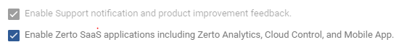

1. ZVM must have port 443 open to <https://zerto-mobile-data.zerto.com>
2. User must be registered user in MyZerto with their work email domain address

How to Access “Tenants”

1. Log into MyZerto (www.zerto.com/myzerto)
2. Select “Cloud Control” from the navigation bar – will open in a new tab



1. Select “Tenants”



How to “Add” a new “ZORG” in “Tenants”

1. Click the “Add Tenant” button in the top right



1. Select the appropriate ZORG by clicking on the “ZORG Name” field – note that typing in this field will filter the list.

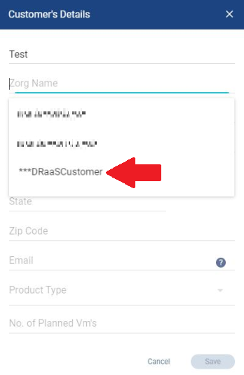

1. Fill in the other required fields.

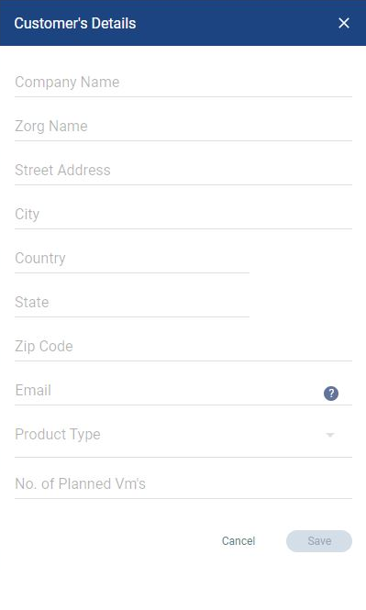

Note: The email address provided will be used for validation. The email address and domain must be unique and cannot be registered to any other of your registered customers. Zerto will not contact this email address and recommends using a non-personal email address such as, “info@customer.com”.

1. Select a product type:
   1. Software Subscription: Zerto Virtual Replication (ZVR) provides protection for virtual machines in Service Provider site.
      1. **Usage for this ZORG is billed at the provider’s regular rate. (list $30)**
   2. Multi Cloud: ZVR Multi-Cloud (MC) enables one-to-many, simultaneous protection and recovery of VMs within on-premise and multiple Service Provider sites, for up to 3 sites
      1. **Usage for this ZORG is billed at the provider’s premium rate. (list $39)**
   3. Enterprise Cloud Customer: Enterprise Cloud Customers (ECC) with an existing perpetual ECE license and a valid maintenance and support agreement for such a license with Zerto, who will now be using a Service Provider for replication for one of their sites
      1. **Usage up to the enterprise customer’s ECE license amount for this ZORG is billed at $0.**
   4. Migration:
      1. **Migration is to be used for customer workloads that will be migrating to, from, or within your cloud sites. Once the customer's migration is complete, the ZORG's product type should be updated to better reflect their ongoing services.**

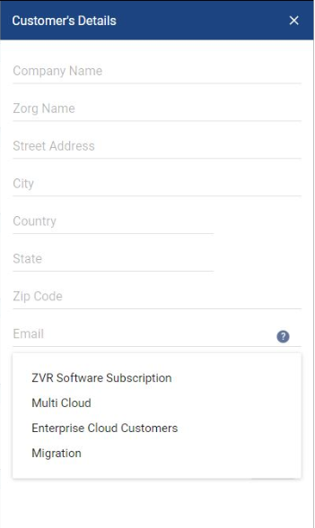

1. Once completed, click the “Save” button

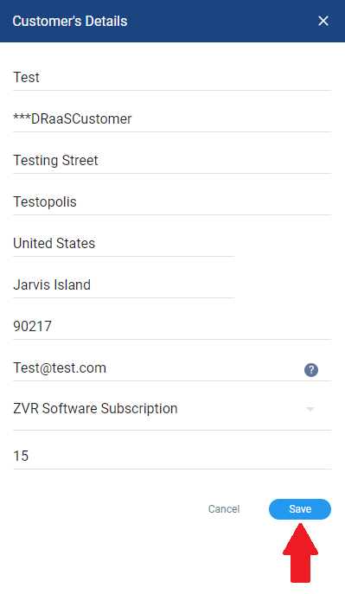

How to edit an existing “ZORG” in “Tenants”

1. Move your cursor over the “ZORG” you wish to edit

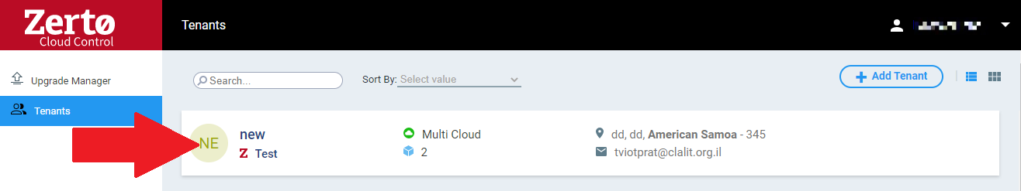

1. Click the “Edit” pencil icon in the top right

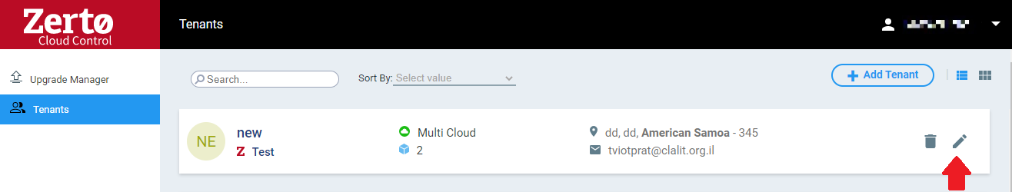

1. Make the desired changes and click the “Save” button



How to Delete a “ZORG” in “Tenants”

1. Move your cursor over the “ZORG” you wish to edit



1. Click the “Delete” trash can icon on the righthand side of the ZORG

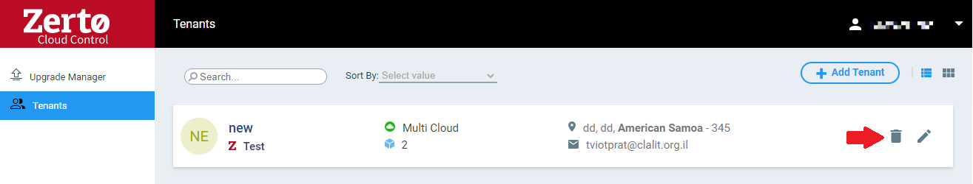

1. A pop-up will appear, select “yes” to delete the ZORG

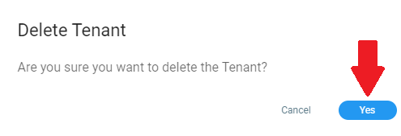

ZORG Name – Customer #1

If you would like to keep more information about your ZORGs and their Zerto Infrastructures, the tables below can be leveraged to do so. As with the rest of this document, these fields can be edited, removed, or added on to fit the specific needs of your Company.

#### ZCC Configuration Details

|  |  |
| --- | --- |
| IP Address |  |
| Subnet Mask |  |
| Gateway |  |
| vSwitch Portgroup |  |

#### Recovery DRaaS Resource Details

|  |  |
| --- | --- |
| ZORG |  |
| Service Profile |  |
| ZSSP URL |  |
| ZSSP User Account |  |
| ZSSP User Password |  |
| Preseed Folder |  |

#### Client Information

|  |  |
| --- | --- |
| Client Acronym |  |
| Domain Name |  |
| NTP Servers |  |
| Antivirus Software |  |
| Mail Server | Not used |
| Notification Email | Not used |

#### Customer vCenter/vCD Server Details

|  |  |
| --- | --- |
| Host Name/IP |  |
| vCenter/vCD Version and Build |  |
| Zerto Service Administrative User |  |
| Site Name |  |
| VMware HA enabled | Not used |

#### Customer ZVM Configuration and Deployment

|  |  |
| --- | --- |
| ZVM Name |  |
| VM ZVM is deployed on | VM name |
| ZVM Version | 8.0u3 |
| ZVM Static IP |  |
| Gateway |  |
| DNS |  |
| Windows Server Version |  |
| Window OS Update responsibility | MSP/Customer |
| Virus scan exclusions: C:\Program Files (x86)\Zerto\Zerto Virtual Replication | Yes/No |
| vCPU | 2 |
| Memory | 4GB |
| NTP configured | Yes/No |
| Local Admin rights granted to MSP | Yes/No |
| Other applications installed on this VM | Yes/No – The answer should ALWAYS be No. This field is to help ensure that |

#### Customer ZVM Site Settings

|  |  |
| --- | --- |
| Site Name |  |
| Site Location |  |
| Contact Name |  |
| Contact Email |  |
| Contact Phone |  |

#### VPGs and Protected VMs

|  |  |  |  |  |  |  |
| --- | --- | --- | --- | --- | --- | --- |
| VM Name | vSphere Network | IP | VM | RPO | Recovery Order (if applicable) | VPG Name |
|  |  |  |  |  |  |  |
|  |  |  |  |  |  |  |
|  |  |  |  |  |  |  |
|  |  |  |  |  |  |  |
|  |  |  |  |  |  |  |
|  |  |  |  |  |  |  |
|  |  |  |  |  |  |  |
|  |  |  |  |  |  |  |

#### Zerto Throttling

If Zerto replication does not use a dedicated network, then throttling may be required during specific application tasks or other reasons. If applicable, please fill in the details below:

|  |  |
| --- | --- |
| Throttle Timeframe | Details |
| 5AM to 8PM Su-Sa | 200Mbps |
| 8PM to 5AM Su-Sa | 250Mbps |

ZORG Name – Customer #2

#### ZCC Configuration Details

|  |  |
| --- | --- |
| IP Address |  |
| Subnet Mask |  |
| Gateway |  |
| vSwitch Portgroup |  |

#### Recovery DRaaS Resource Details

|  |  |
| --- | --- |
| ZORG |  |
| Service Profile |  |
| ZSSP URL |  |
| ZSSP User Account |  |
| ZSSP User Password |  |
| Preseed Folder |  |

#### Client Information

|  |  |
| --- | --- |
| Client Acronym |  |
| Domain Name |  |
| NTP Servers |  |
| Antivirus Software |  |
| Mail Server | Not used |
| Notification Email | Not used |

#### Customer vCenter/vCD Server Details

|  |  |
| --- | --- |
| Host Name/IP |  |
| vCenter/vCD Version and Build |  |
| Zerto Service Administrative User |  |
| Site Name |  |
| VMware HA enabled | Not used |

#### Customer ZVM Configuration and Deployment

|  |  |
| --- | --- |
| ZVM Name |  |
| VM ZVM is deployed on | VM name |
| ZVM Version | 8.0u3 |
| ZVM Static IP |  |
| Gateway |  |
| DNS |  |
| Windows Server Version |  |
| Window OS Update responsibility | MSP/Customer |
| Virus scan exclusions: C:\Program Files (x86)\Zerto\Zerto Virtual Replication | Yes/No |
| vCPU | 2 |
| Memory | 4GB |
| NTP configured | Yes/No |
| Local Admin rights granted to MSP | Yes/No |
| Other applications installed on this VM | Yes/No – The answer should ALWAYS be No. This field is to help ensure that |

#### Customer ZVM Site Settings

|  |  |
| --- | --- |
| Site Name |  |
| Site Location |  |
| Contact Name |  |
| Contact Email |  |
| Contact Phone |  |

#### VPGs and Protected VMs

|  |  |  |  |  |  |  |
| --- | --- | --- | --- | --- | --- | --- |
| VM Name | vSphere Network | IP | VM | RPO | Recovery Order (if applicable) | VPG Name |
|  |  |  |  |  |  |  |
|  |  |  |  |  |  |  |
|  |  |  |  |  |  |  |
|  |  |  |  |  |  |  |
|  |  |  |  |  |  |  |
|  |  |  |  |  |  |  |
|  |  |  |  |  |  |  |
|  |  |  |  |  |  |  |

#### Zerto Throttling

If Zerto replication does not use a dedicated network, then throttling may be required during specific application tasks or other reasons. If applicable, please fill in the details below:

|  |  |
| --- | --- |
| Throttle Timeframe | Details |
| 5AM to 8PM Su-Sa | 200Mbps |
| 8PM to 5AM Su-Sa | 250Mbps |

Internal MSP Application Recovery Plans

The section below is designed to be used for internal VPGs that you, the Cloud Service Provider protects with Zerto. Customer VPG recovery plans should be added to the “Zerto DRaaS Customer DR Runbook” document and not this one. The following pages can be copied and pasted as many times as needed depending on the number of applications (VPG’s) that need to be planned for. Remember to update the Contents table at the beginning of this document to reflect new sections.

If a complete workload failover is needed, then all of the following VPG’s should be failed over in the order in which they appear below. If a single VPG needs to be failed over, then you can skip to that specific VPG section.

VPG Failover Order

1. <VPG #1>
2. <VPG #2>

#### VPG #1 – CHANGE ME

|  |  |  |  |
| --- | --- | --- | --- |
| Application Owner Information | | | |
| Department | Accounting |  | |
| RTO SLA | 1 Hour |
| Primary Contact | John Doe | **Phone** | 123-456-7890 |
|  |  | **Email** | john@myco.com |
| Secondary Contact | Jane Doe | **Phone** | 123-456-7890 |
|  |  | **Email** | jane@myco.com |

|  |
| --- |
| Overview of services provided by this application |
| Text about the services that are provided by this application and what happens when this application is offline. |

|  |
| --- |
| What events justify a failover of this application |
| Describe the business impact that this application has on profits when it is offline and what does and what does not qualify this application to be failed over. It should be in simple terms so that anyone can make an educated decision. |

|  |
| --- |
| Important Information to remember when failing over this application |
| Include any notes on what applications to check on the servers once they are online at the recovery site. Also include any tips and tricks that may be needed to recover the applications that may not be obvious to someone who doesn’t work with them on a day to day basis. |

Procedure for Failover of <VPG NAME> to Recovery Site

1. In the Zerto User Interface set the operation to LIVE and click FAILOVER.  
   The Failover Wizard is displayed.  
   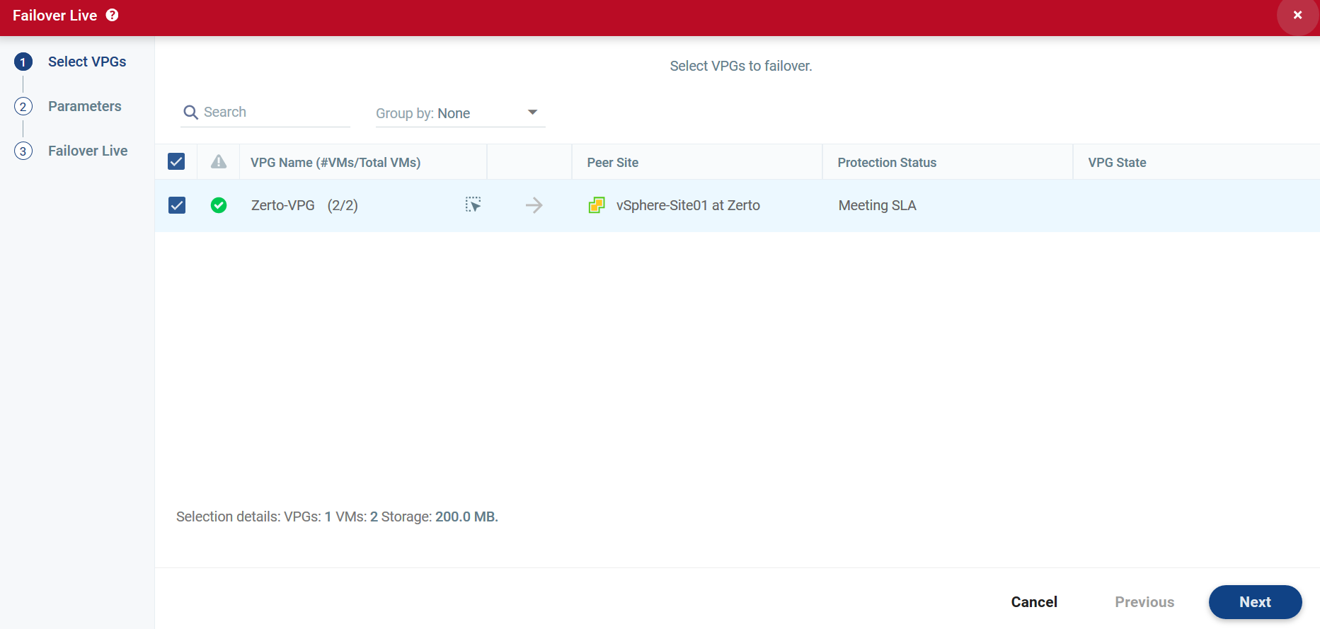   
     
   Notes: <Insert any notes you need to here… .for example if this VPG needs to be failed over before or after another VPG>
2. In the Failover wizard, Select the <Application Name Here> VPG.
3. Click Next to review the failover settings, verify that the proper Checkpoint has been selected.  
   The Commit Policy should be set to <Auto-Commit, 10 minutes>, and the Reverse Protection should be unchecked at this time.  
   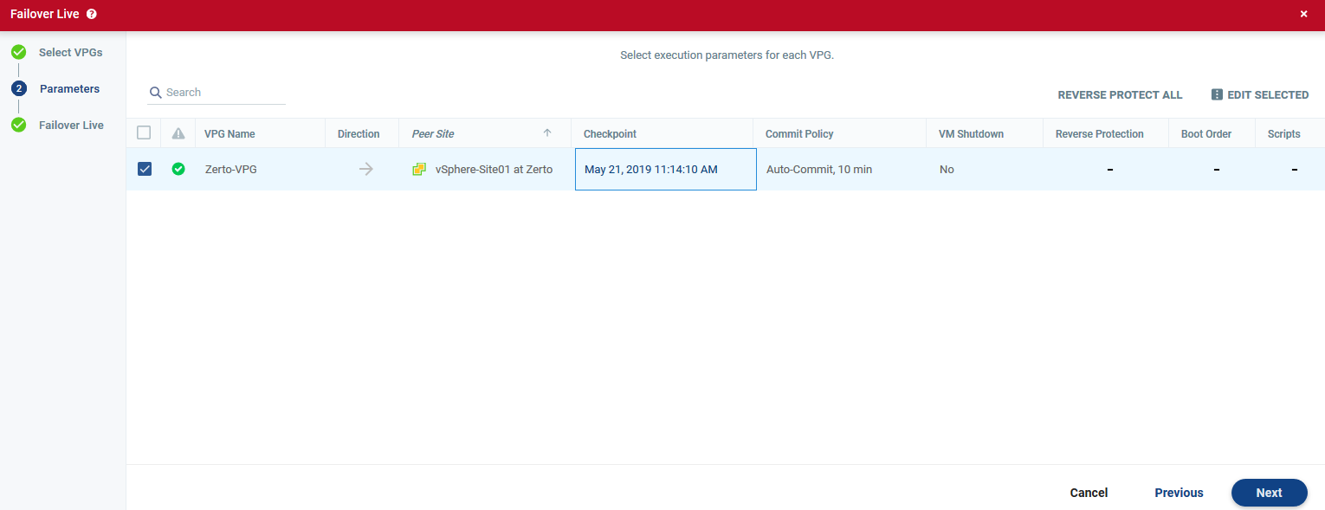
4. Click Next to advance to the Start Failover section of the wizard. On this page click START FAILOVER to initiate the transition of the application to the recovery site.  
   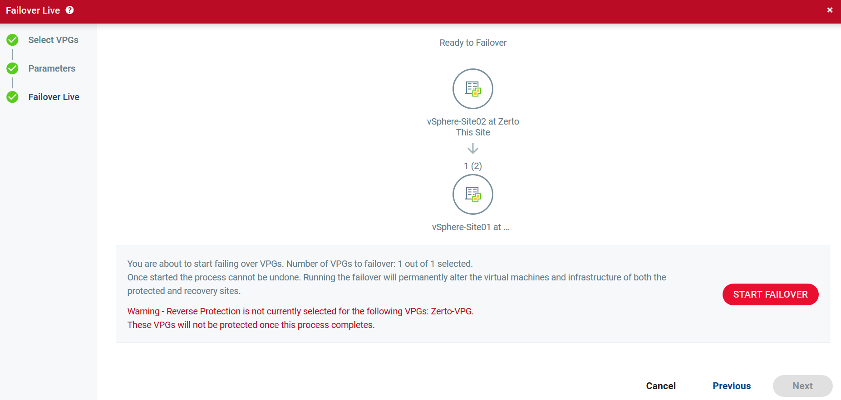
5. Once the Application has been verified to be working you can return to the Zerto User Interface to Commit the failover, or after 10 minutes the failover will be automatically committed.
6. At this point the application should be up and running and Zerto should show the VPG in a “needs configuration” state. This is normal until reverse replication has been configured. Contact Zerto Technical Support to initiate the reverse replication and verify that things are working properly.

Troubleshooting and Support

This section is a basic overview of what actions need to be taken when an issue arises within the Zerto environment. It reviews initial troubleshooting steps, who to contact internally and externally, and how to engage Zerto’s Support department.

**IMPORTANT:**

All Support cases must be opened by you, the MSP. The customer will not be allowed to open a case directly with Zerto and will be turned away with the request to contact their MSP. Customer’s should never be asked to open a Support case simply because of the basic infrastructure built and controlled by the MSP, the MSP’s license ownership, and MSP’s agreement with Zerto. The MSP will always be the first line of defense for all Zerto related issues.

Initial Troubleshooting Steps and Knowledgebase Articles

Basic Initial Troubleshooting Steps

**1:** The first step in troubleshooting your Zerto environment will always be the review of the alert/event itself and determine where the issue is occurring. This will help to detail what the issue is and may point at an easy fix to the problem. More information on the alert/event can always be found under the ZVM’s Monitoring tab.

**2:** If the alert is not clear, the next step would be to research the issue within the myZerto.com website. You can search for answers within our Knowledge Base articles, forums, and our online documentation listing on our site.

**3:** If you are unable to quickly remedy the issue, please contact your Zerto Account team and create a Zerto Support ticket. Once the Support case is created, a representative will reach out as quickly as possible to work directly with you and your end-customer. Note: Customers will not be allowed to open the Support case. The MSP will be required to open the case on their end.

Alerts and Event Logs:

Whenever an issue arises, Zerto will immediately send an alert to the ZVM that the issue occurred at, and the ZVM it is paired peer. This will always be the first step in troubleshooting Zerto. To be clear, in a MSP environment with ZCCs in place, only the end-customer’s alerts will show on their ZVM. Those alerts will transfer directly to the MSP’s target ZVM, but the MSP’s alerts will never appear on the end-customers ZVM, per the ZCC security protocol. This protects the MSP and its multi-tenancy customers from ever crossing alerts or inducing the end-customer into an unnecessary panic for a negligible alert or event on the MSP’s side.

An often-overlooked feature is that the alert/event on the ZVM will not only give a basic description of the issue on at hand, but it will also link the user directly to Zerto’s online administrator guide to provide further insight into what could be causing the problem. The images below show where that link is located on the alert or event within the ZVM Monitoring tab:

Alerts:

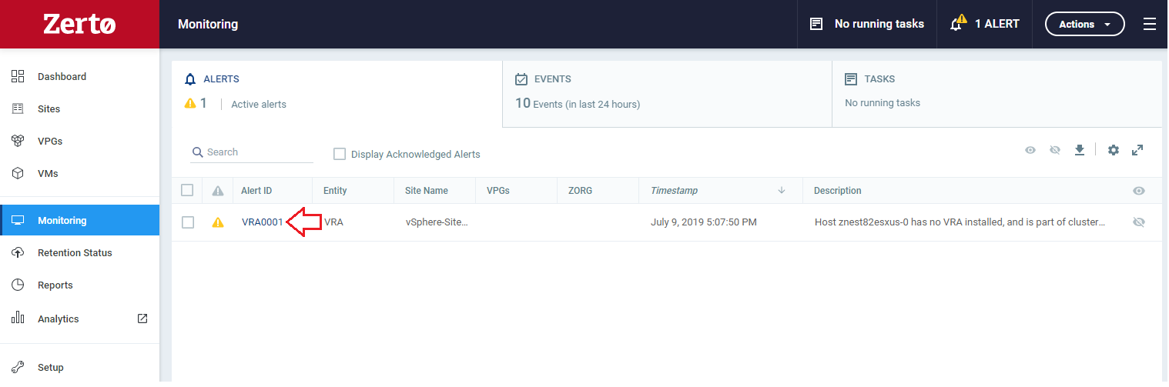

Events:

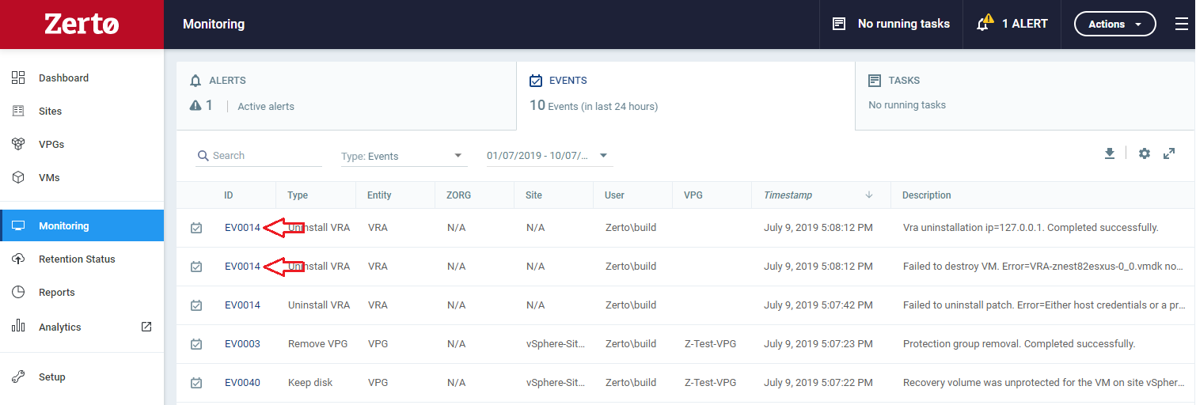

Knowledgebase Articles:

Zerto continuously creates and updates their knowledgebase articles for their customers. Most KBs are direct resolution articles for common obstacles within the product’s implementation into varying infrastructure environments.

<https://www.zerto.com/myzerto/knowledge-base/>

Zerto Cloud Specific Articles:

<https://www.zerto.com/myzerto/section/cloud/>

Key Troubleshooting Knowledgebase Articles:

With the release of ZVR 7.0 and beyond, users can now access their VRAs and ZCCs without the requirement of contacting Zerto’s Support department. Below is Zerto’s documentation on how to access the unique ZCC and VRA login credentials within your environment. Note: If you are on ZVR 6.5 and below, you will need to contact Zerto Support to gain access to the VRAs and ZCC.

Connecting to a VRA via SSH

<https://www.zerto.com/myzerto/knowledge-base/connecting-to-a-vra-via-ssh/>

Connecting to a ZCC via SSH

<https://www.zerto.com/myzerto/knowledge-base/connecting-to-a-zcc-via-ssh-and-performing-connectivity-troubleshooting-steps/>

Field Notice Articles:

<https://www.zerto.com/myzerto/section/field-notice/>

Internal Cloud Provider Emergency Contacts:

Below is a form fillable table for organizing key internal individuals that should always be contacted in the event of an issue with Zerto. This table can also be used to setup secondary contacts in the event that a primary contact is unreachable:

|  |  |  |
| --- | --- | --- |
| Name and Title | Contact Method | Contact Info |
| CTO/Zerto Admin | Office Phone | 123-456-7890 |
|  | Cell Phone | 123-456-7890 |
|  | Home Phone | 123-456-7890 |
|  | Work Email | JD@myco.com |
|  | Personal Email | [personal@hotmail.com](mailto:personal@hotmail.com) |
| System Admin | Office Phone |  |
|  | Cell Phone |  |
|  | Home Phone |  |
|  | Work Email |  |
|  | Personal Email |  |
| Network Admin | Office Phone |  |
|  | Cell Phone |  |
|  | Home Phone |  |
|  | Work Email |  |
|  | Personal Email |  |
| Storage Admin | Office Phone |  |
|  | Cell Phone |  |
|  | Home Phone |  |
|  | Work Email |  |
|  | Personal Email |  |

Zerto Cloud Provider Contacts:

Below is a form fillable table for the MSP’s current Zerto Account Team contact information. If an issue needs escalating, further review, or you simply want to ask your account team about a problem prior to opening a support case, please do not hesitate to contact the below individuals:

|  |  |  |
| --- | --- | --- |
| Name and Title | Contact Method | Contact Info |
| YOUR ZERTO ACCOUNT MANAGER | Office Phone | 123-456-7890 |
|  | Cell Phone | 123-456-7890 |
|  | Home Phone | 123-456-7890 |
|  | Work Email | JD@myco.com |
|  | Personal Email | [personal@hotmail.com](mailto:personal@hotmail.com) |
| YOUR ZERTO CLOUD ARCHITECT | Office Phone |  |
|  | Cell Phone |  |
|  | Home Phone |  |
|  | Work Email |  |
|  | Personal Email |  |

Zerto Support Services

Zerto solutions deliver enterprise-class support features that are built into all our products. These features include real time alerts when RPO/RTO targets are not being met, network degradation alarms and reminders to check configurations and Virtual Protection Groups. Zerto solutions are also backed by global support centers that provide on-demand access to an expert team of support engineers.

Through [case management](https://www.zerto.com/myzerto/support/manage-open-and-closed-cases/), users can track and review existing tickets, as well as open new tickets. Additionally, full access to [existing knowledge base articles](https://www.zerto.com/myzerto/knowledge-base/) is provided. The Zerto Support Team continues to add content to the knowledge base, documenting their experiences to provide you with best practices. Zerto maintenance and support contracts include the following:

|  |  |  |
| --- | --- | --- |
| Support Feature | Standard Support Option | Premium Support Option |
| Global Technical Support | Monday – Friday: 9 AM - 5 PM* | 365 X 24 X 7 |
| Target Response Time | * Severity 1: 4 hours * Severity 2: 1 business day * Severity 3: 3 business days * Severity 4: 5 business days | * Severity 1: 1 hour * Severity 2: 4 hours * Severity 3: 1 business day * Severity 4: 3 business days |
| Remote Support | Included | Included |
| Self-service Portal | Included | Included |
| Root-cause Analysis | Included | Included |
| Product updates, maintenance releases and hot fixes. | Included | Included |
| 24x7 access to support tools including knowledge base, forums and software updates | Included | Included |
| Support Requests | Unlimited | Unlimited |
| Priority Queuing | No | Yes |

* = Customer’s local time

Severity Definitions:

Zerto Support tickets are categorized according to “severity,” which considers the overall impact the customer is experiencing. The support ticket severity should be based on the guidelines of the Case Severity Definitions provided below. Since it is not possible to define every possible technical situation or impact, these definitions are intended to serve as guidelines.

Case prioritization is based upon several criteria including case severity, case creation timeline, business impact, customer’s contract, etc. When choosing a severity for a new ticket, please include the detailed symptom and problem description along with any other pertinent details that may influence case prioritization. Failure to supply critical information may result in delay of service.

**Severity 1:** A severe problem or degradation preventing replication from an existing production environment. Replication is down. Business cannot be conducted, and productivity is severely impacted. Unable to recover or migrate an application and no workaround is available. Production environment is impacted or unavailable.

Examples:

* Failed failover (test or live)
* ZVR is unusable
* Active blue/purple screen of death (BSOD/PSOD)
* Issue requiring 24×7 focus by Zerto Support and customer

**Severity 2:** A partial failure or degradation where ZVR is not at full strength, but replication is available. Productivity is partially impacted. Recovery is possible, however, RPO or RTO is not meeting SLA.

Examples:

* Site disconnections
* Cannot add VM to VPG
* Create/edit VPG failure
* VRA out of memory
* New install of ZVR fails

**Severity 3:** A mild, non-critical impact. A limited condition is occurring; however, it can be readily circumvented with a workaround.

Examples:

* ZVR issues in a test environment
* Issue has been resolved but root cause not yet identified

**Severity 4:** Query about product functionality. ZVR is not impacted.

Examples:

* “How-to” question
* Question regarding documentation

Case Escalation Guidelines:

If you require a more urgent response or need your case to be reassigned due to an engineer reaching their off hours, please choose the escalation option. In your request please be prepared to discuss the following:

1. Case number
2. Reason for escalation
3. Detailed symptom and problem you are experiencing

You can request an escalation two ways:

Option 1: In MyZerto.com under the Support section and Case Management, you can select 'Escalate' on your case.

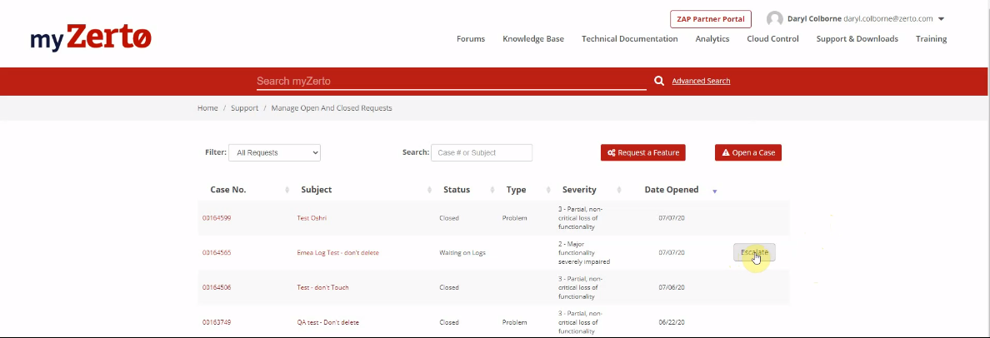

Give the reasoning for escalating and any details you want to include.

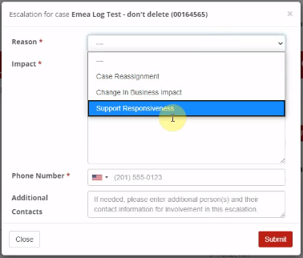

After submitting, your escalation request will be reviewed, and a Zerto Support manager will reach out to you directly.

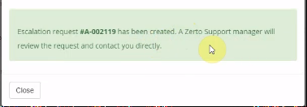

Option 2:  You can contact our Support team directly by calling one of the numbers listed:

Please be prepared with your case number, the reason for the escalation, and a detailed problem or symptom you are experiencing.

Call the Zerto Support Line:

|  |  |  |  |
| --- | --- | --- | --- |
| Country | Support Contact | Country | Support Contact |
| Australia | +61-1800-466-227 | India | +000-800-100-4056 |
| Canada | +1-866-271-3145 | United Kingdom | +44-800-088-5495 |
| China | +86-400-120-8535  +10-800-713-1114(N)  +10-800-130-1074(S) | Germany | +49-32221090005  +0800-184-4995 |
| Hong Kong | +800-905-393 | Japan | +0800-111-9335 |
| Indonesia | +001-803-015-203-9790 | South Korea | +003-0813-1992 |
| Singapore | +800-492-2306 | United States | +1-866-271-3145 |
| Taiwan | +00801-14-7242 |  |  |

For additional information on Zerto, our products and support, please go to www.zerto.com or contact your regional account manager.

#### Creating a Support Ticket

Support tickets can be opened directly in the Zerto User Interface. Creating a support ticket in the Zerto User Interface simplifies the submission process, since much of the information that is required when entering a ticket using the Zerto Support Portal, such as the version and build numbers, is automatically added to the ticket when it is submitted via the Zerto User Interface. In addition, when the ticket is submitted, a snapshot of the current environment is also attached to the ticket. The snapshot information includes the lists of alerts, events, tasks, VPGs, and virtual machines that are protected. This information is used to help Zerto resolve the ticket quickly and, whenever possible, without the need to request more information from you.

**Note:** The clocks on the machines where Zerto Virtual Replication is installed must be synchronized with UTC and with each other (the timezones can be different). Zerto recommends synchronizing the clocks using NTP. If the clocks are not synchronized with UTC, submitting a support ticket can fail.

To open a support ticket:

**Method 1: Opening a case from the ZVM (*Recommended)**

**1.** In the Zerto User Interface, click *SETTING* ( ) in the top right of the header and select *Submit Support Ticket*.

The *Open Support Ticket* dialog for the site is displayed.

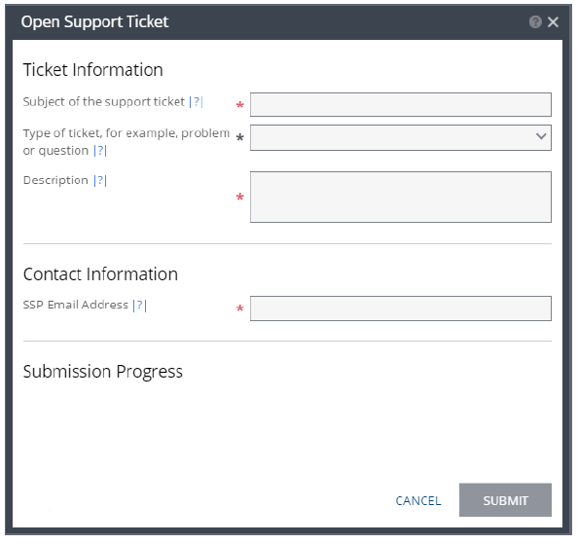

**2.** Specify the ticket details:

Subject – The subject of the support ticket.

Type – The type of ticket being opened.

Description – A description of the ticket in addition to the information supplied in the subject.

SSP Email Address – A valid email address registered with Zerto, with permission to open tickets.

**3.** Click *SUBMIT*.

The ticket is then processed, and its progress is displayed. If the email address is not valid, the ticket is rejected. Once the ticket submission starts, it cannot be canceled.

**Method 2: Opening a case via myZerto.com**

1. Login to the myZerto.com site
2. Navigate to the “Support & Downloads” page via the tab on the top right and select the “Open a Case” button block
3. Fill in the form accordingly and click the “Submit” button at the bottom.

**Method 3: Opening a case from the Analytics page**

1. While on the Zerto Analytics page, left-click your name and view the options in the dropdown.
2. Select the option for “Open a Case”, which will redirect you to the case submission form on our myZerto.com support and downloads page:

